
A Parish Church of the Diocese of Huron Founded 1862

Annual Vestry – February 8th, 2026
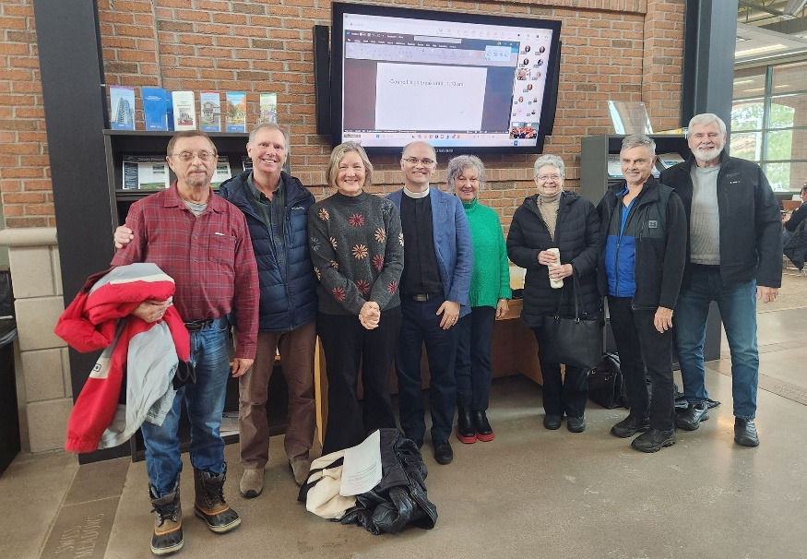
Deepening Our Faith:
Growing in Our Relationships

St George’s is a family of faith, growing together through our service to God and those beyond our doors as we follow in the steps of Jesus Christ.

Vestry Reports for the Year 2025
Rector: The Rev’d Canon Dr. Grayhame Bowcott
166 Russell St. E., P.O. Box 9, Clarksburg ON. N0H 1J0
Email: parishofthebluemountains@gmail.com Web site: parishofthebluemountains.ca Telephone: 519.599.3047
DIRECTORY OF ITEMS IN THIS PACKAGE

Directory Page 2
Agenda Page 4
Vestry Prayer Page 6
2025 Parish Council Members Page 7
Minutes of Vestry February 2, 2025 Page 9
The Bishop of Huron’s Letter Page 18
Rector’s Annual Report Page 20
Director of Music Ministry’s Report Page 25
Report of our Honourary Associate Priest Page 27
Report from our Diaconal Postulants Page 28
Pastoral Statistics Report & Memorial Prayers for 2025 Page 31
Annual Congregational Statistics Report Page 33
Attendance/Engagement Report Page 37
Churchwardens’ Annual Report Page 37

Ministry Committee Reports – 2025
Garden of Remembrance Scattering Garden Page 40
Report From Synod 2025 Page 42
Safe Church Report for 2025 Page 43
Prayer & Care Ministry Page 44
The ‘Take Time’ Women’s Prayer Group Page 45
St. George’s Chancel Guild Page 45
Sanctuary Lamp Report Page 46
Altar Flowers Report Page 47
Altar Servers Guild Page 48
Monday Bridge Group Page 48
Tuesday Mahjong Group Page 49
St. George’s Cares – Seniors Meal Program & Catering Page 49
Outreach to Mexican Parishioners Page 51
Community Corn Roast Page 52
The Early Birds – 8:00 a.m. Congregation Page 53
Social Media & Advertising Page 53
The Primate’s World Relief and Development Fund Page 54
St. George’s Plant Sale 2025 Page 56
St. George’s Garden Party - Fish Fry 2025 Page 58
Carriage House Winter Storage Page 59
St. George’s Men’s Group Page 60
Sexton’s Report (Building and Property Maintenance) Page 61
Anglican Church Women Page 62
ACW Annual Financial Statement Page 64

Treasurer’s Report Page 66

Appointments and Election of Officers for 2026 Page 67

Resources for Ministry
St. George’s 2025 Year-to-Date Financials + Proposed 2026 Budget A.D. 1
Asset Management Report A.D. 3
Envelope Secretary’s Report (Donation Profile 2025) A.D. 4
Five Year’s Income and Expense (+ 2026 Budget) Comparison A.D. 5
Letter of Accounting Standards from St. George’s Accountant A.D. 6

ANNUAL VESTRY MEETING
February 8nd, 2026 at 11:00 a.m.
Hosted In-person and on Zoom:
https://us02web.zoom.us/j/83799824457

Agenda
1. Call to order
2. Attendance roll call
4. Election of Vestry Clerk (motion needed)
5. Motion to Adopt the Agenda
6. Motion to Adopt the Minutes of Vestry February 2nd, 2025.
7. Business arising from the Minutes
8. Motion to receive Common Consent List (Pages 40 - 64)
9. Bishop’s Letter, Rector’s Report and Ministry Team Leader Reports
10. Parish Statistical Report & Memorial Prayers
11. Churchwardens’ Report
12. Ministry Committees and Group Reports
13. Treasurer’s Report
a) 2025 Year-End financial statements.
b) Envelope Secretary’s Report for 2025.
14. New Business:
a) A 10 minute presentation from Michelle Hughes, Diaconal Postulant, sharing the details of our upcoming WAYGATE Project, as has been approved by the Town of the Blue Mountains.
b) Any additional new business (to be decided by Item #5, above)

15. 2026 Appointments and Election for Parish Council
a) Rector’s appointments
b) Names standing for election
(from the Nominations Chair: Dr. Garth Martin)
c) Names standing for Congregational Committees
d) Motion to open the floor to further nominations
e) Motion to close nominations
f) 2026 Parish Council and Committee Chairs election
16. Motion to adopt all reports as they have been presented
17. Proposed Budget for 2026
a) Budget as endorsed by the 2025 Parish Council (on Wed. January 28th).
b) Q & A regarding the 2026 budget
c) The 2026 Budget Presented in Narrative Form
d) Motion to adopt the 2026 Budget
18. Motion to Adjourn
19. Close with the Doxology



2026 VESTRY OPENING PRAYER

Priest: Before we enter into this time of the business of our church,
Let us ground ourselves in the presence of God
And in our relationship with Christ through prayer.

Priest: The Lord be with you.
All: And also with you.

Priest: Let us pray,

Almighty God, we give you thanks for the many blessings that we have received at your hand in this past year: blessings of community service, relationships with others, generosity in caring, and in the times of worship and faith that you have shared with us. As we look to another year of ministry and service, we ask you to bless the leadership of our church, to inspire each of us in the ways we learn, care and pray; and to lead our congregation of St. George’s into another year of outreach and faithfulness.

This we ask in Jesus’ name.

AMEN

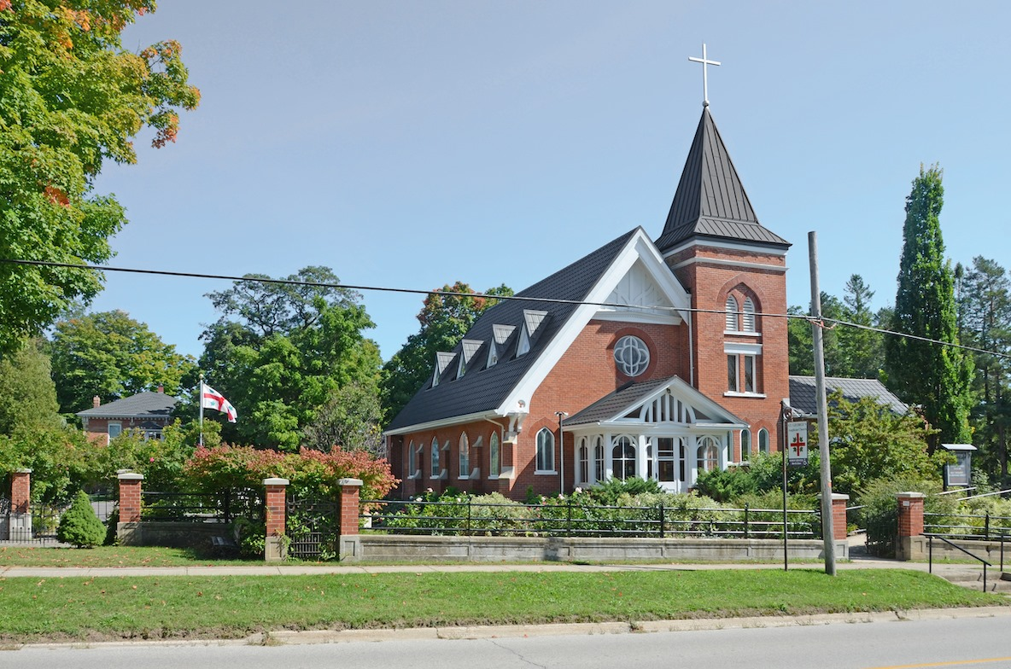

ST. GEORGE’S 2025 PARISH COUNCIL

The Rev’d Canon Dr. Grayhame Bowcott Rector, Priest and Pastor
The Venerable Judy Walton Honourary Associate Priest

Adele Denyer People’s Warden – Cong. Relations & ACW Chair
Brian Blackie Rector’s Warden Sharon Wigle Deputy People’s Warden + Youth Ministries
Caroline Bacher Deputy Rector’s Warden + Chancel Guild
Gloria Andrews Emeritus Warden & Sunday Livestreaming
Tom Kern Emeritus Warden & Parish Sexton
Donna Whiteside Diaconal Postulant
Michelle Hughes Diaconal Postulant
John Hethrington Member at Large – 8 am Rep/Advert./Plant Sale
Hazel de Burgh Member at Large – Plant Sale/Parish Photographer
Lynn Reid Member at Large + Catering
Doug McWhirter Member at Large + Emeritus Sexton
Wayne Powney Member at Large + Meals Delivery
Steve Granger Member at Large – Town Council Liaison
Janet Cringle Director of Music (ex-officio)
Gwyneth Green Parish Council Secretary
Gary Huber Treasurer (ex-officio)
John Leckie Treasurer (ex-officio) & Envelope Secretary
Laura Woolner* Past Seminarian & Social Media
*Appointed as a Postulant for Ordained Ministry by the Bishop of Qu’Appelle

NON-COUNCIL MEMBERS/ COMMITTEE CHAIRS

Donna Whiteside Pastoral Assistant to the Rector
Carolyn Leonetti Parish Accountant
Dr. Garth Martin Safe Church Chair
Richard Griffith Primate’s World Relief and Development Fund Chair
Adele James Anglican Church Women - President
Jan Nicholson Take Time (Women’s Prayer Group)
Caroline Bacher Altar Server
Sue Abbots, Caroline Bacher,
Ruth McWhirter and Adele James Chancel Guild Seasonal Coordinators
Judith Helston Presence Candle Coordinator
Mary Sandell Sanctuary Flowers Coordinator
Donna Whiteside Prayer and Care Group Coordinator
Elaine Beard, Richard Griffith
and Michelle Hughes St. George’s EnviroAction Leaders

Jim Moore Garden of Remembrance
(Scattering Garden) Chair
Hank Bouwman Carriage House Manager
& Men’s Group Coordinator
Tom Kern Parish Sexton
Adele James & Doreen Taylor St. George’s Cares Seniors Meals
Bruce Whiteside Custodian
Jon McKinlay Parish Handyman
Gloria Andrews Sunday Worship Media Technician
Laura Woolner Communications and Social Media

A Special Thank You to Each of These for Their Dedication of Time and Ministry!

2025 ANNUAL VESTRY MEETING – MINUTES
St. George’s The Parish of the Blue Mountains
Hosted on Zoom and In-Person
Sunday February 2, 2025

- Call to Order
The Chair of Vestry is The Rev’d Canon Dr. Grayhame Bowcott - Rector, Priest and Pastor
The Chair called the meeting to order at 10:57 AM.
Dr. Bowcott acknowledged the attendees and extended a welcome to those who are attending this Vestry at St. George’s for the first time.
The Chair verified that all were in receipt of the documents pertaining to this meeting. Dr. Bowcott noted the addendum to the Treasurer’s Report entitled St. George’s Resources for Ministry Market Value Endowments as of December 31, 2024.
The Chair thanked those who had provided the luncheon for Vestry attendees.
The Chair reviewed the procedure for taking attendance.
The Chair announced that Dr. Garth Martin had sent in Regrets.

- Election of Vestry Clerk
Michelle Hughes moved to elect Gwyneth Green as Vestry Clerk.
Seconder Todd Kaufman
CARRIED UNANIMOUSLY

- Agenda
In response to a Question from the Floor, The Chair recognized Bruce Whiteside’s role in keeping the church entrances safe.
The Chair tabled a discussion of Parish compliance with municipal safety regulations.
Hazel de Burgh moved to adopt the Agenda as presented.
Seconder Michael Martin
CARRIED UNANIMOUSLY

- Minutes
Corrections to the Vestry Report 2025
Page Number | Error | Correction
Cover Page | Vestry Reports for the Year 2025 | Vestry Reports for the Year 2024
Page 13 #38 | Carolyn Leckie | Carolyn Leonetti
Page 16 #39 | Motion omitted | Add: Doug McWhirter moved to adopt the 2024 Budget as presented.  Seconder Mike Seagram  Hearing no further questions or comments from The Floor to the Motion, Canon Bowcott called for a Vote.  CARRIED UNANIMOUSLY
Page 38 | We wish to thank professional gardener Anne Fisher | We wish to thank our gardeners The Crack’d Pot and Marsha Franklin.
Page 63 | Cooked by Rybee’s | Cooked by Ribey’s

Donna Whiteside moved to accept the amended Minutes.
Seconder Wayne Powney
CARRIED UNANIMOUSLY

- Business arising from the Minutes.
Hearing no need to add Business arising from the Minutes, the Chair carried on with the agenda as presented.

- Motion to receive Comment Consent List
Judith Helston moved to receive the Common Consent List.
Seconder John Hethrington
CARRIED UNANIMOUSLY

- Bishop’s Letter
The Chair acknowledged the Bishop’s Letter, dated January 2025. The Diocesan Plan is entitled “Turning to Grace”. A Parish e-blast will list the upcoming strategies to achieve the goals as stated in Turning to Grace.

- Rector’s Report
“Sharing Our Story”
Communicating the Work of the Gospel as offered by the hands and hearts of our Parish Church.
The Parish will seek to communicate its story to the Community outside our Parish. Invitational strategies will include a re-vamping of our social media, signage and advertisements. The Parish participated in the Seniors’ Fair for the first time. The Chair asked Vestry to share ideas for further strategies to members of Parish Council.

- Music Ministry Report – Janet Cringle, Director of Music
Further to the written report, Ms. Cringle acknowledged the recent deaths of beloved choristers. Ms. Cringle will welcome and train new choristers. The Chair noted the presence of male singers in the Choir.

- A Report from our Honorary Associate Priest – The Venerable Judith Walton
Further to the written report, the Chair invited the Parish to read about Archdeacon Walton’s new role as Spiritual Director at St. George’s.

- Monica Wilkinson moved to accept the Bishop’s Letter, the Rector’s Report, the Music Ministry Report and the Report from the Honorary Associate Priest.
Seconder Hazel de Burgh
CARRIED UNANIMOUSLY

- Pastoral Statistics Report
Please see Page 28 of the Vestry report.
Further to the written Report, the Chair acknowledged the support which The Venerable Judith Walton gave to bereaved families.

- Requiescat in Pace
The Chair read aloud the names of the deceased and the names of those whose ashes were scattered in the St. George’s Memorial Garden. The Chair led Vestry in a Prayer.

- Annual Statistical Report for 2024
Worship Participant Report
Attendance Engagement Report
The Chair outlined the categories represented in the statistics. Worship Services also take place outside of the Church. Dr. Bowcott drew attention to the Average Attendance, including the on-line viewership. The Parish will consider how to engage on-line viewers in Parish life.
A show of hands revealed that approximately 35% of Vestry attendees had joined the Parish within the last ten years.

- Churchwardens’ Report for 2024
Further to the written Report, the Wardens expressed thanks to each other and to all who participated in the Parish events.
The Chair recognized the work of the Wardens and the transition of Tom Kern and Gloria Andrews to the status of Emeritus Wardens.

- Ruth McWhirter moved to accept the following:

Pastoral Statistics Report
Annual Statistics Report for 2024
Worship Participant Report – 2024 Review
Attendance Engagement Report
Churchwardens’ Report for 2024

Seconder Hank Bouwman
CARRIED UNANIMOUSLY

MINISTRY COMMITTEE AND GROUP REPORTS

- Garden of Remembrance Report 2024
Further to the written Report, Jim Moore announced the addition of name markers and the revised fee schedule.
The Committee will invite -
- Pre-planning opportunities
- A campaign for donations to support the upkeep of the garden, with special attention directed to those families who have lost family members and whose ashes are scattered in the Garden.
- A description of the Garden of Remembrance on the Parish website.

- Report from the Diocese of Huron Synod 2024
Further to the written Report, The Chair stated that he, Donna Whiteside and Michelle Hughes attended Synod. The Diocese has reduced Synod to a one-day session to reduce expenses.

- Community Outreach Initiatives – New!
Further to Michelle Hughes’ written Report, The Chair acknowledged Richard Griffith’s mentorship of the new Tiny Forest initiative.

- Indigenous Outreach Ministries – New!
The Chair thanked Hazel de Burgh for initiating and helping to coordinate the Blanket Exercise of November 9, 2024.
Further to the written Report, Hazel de Burgh and Dr. Bowcott stated that they will look for alliances with the Saugeens First Nations after delivering a donation of funds raised at the Blanket Exercise.
The Chair stated that the Diocese of Huron has commissioned Red George to supply the artwork for the upcoming Synod.
The Chair will invite Red George to re-visit St. George’s.

- Safe Church Annual Report for 2024.
Further to the written Report, the Chair acknowledged Dr. Garth Martin’s work in maintaining full compliance with all Safe Church protocols.

- Prayer and Care Ministry
Further to the written Report, Donna Whiteside invited new members. The Chair told Vestry that all Prayer requests are held in confidence. The Chair stated that this is a vital Ministry.

- Our Women’s ‘Take Time’ Prayer Group
Further to the written Report, Jan Nicholson invited new members. The Chair stated that there are books available, at no cost, for those interested in reading Holy Moments.

- St. George’s Photo Directory Project – New!
Further to the written Report, The Chair stated that photos will be posted on a magnet board which will be displayed in the large Parish Hall. The Chair recognized the high quality of the photos and the hours of work put in by Hazel de Burgh for this project.

- St. George’s Chancel Guild
The Chair thanked Sue Abbotts and her fellow Altar Guild members. Sacristans and new Altar Guild members are invited to join those who prepare the Church for Worship Ministries.

- The Sanctuary Lamp
There are three Sanctuary Lamps in the Church. Judith Helston coordinates this Ministry.

- Sanctuary and Altar Flowers
The Chair thanked Mary Sandell for her leadership in this Ministry.

- St. George’s Altar Servers Guild
Further to the written Report presented by Donna Whiteside, The Chair welcomed those interested in being Servers.

- Monday Bridge Group
Further to the written Report, Judith Helston spoke on behalf of Elizabeth Ross and invited new Bridge players. The Chair acknowledged the donations from this group and thanked Bruce Whiteside for setting up the room for the players.

- Tuesday Mahjong Group – New!
Adele James said that this group will make donations to St. George’s.

- St. George’s Cares
Outreach Meal Program and Catering Group
Further to the written Report, Adele James and the Chair acknowledged the work of parishioners and of those outside our Parish who regularly help each Thursday. The Chair has received expressions of gratitude from recipients who enjoy the meals and the chats with the deliverers. This is the only meals-for-Seniors program in the Town of the Blue Mountains.

- Outreach to Mexican Parishioners
Further to the written Report, Jim Moore stated that he thinks of this Outreach as time with friends.

- The Annual Community Corn Roast
Further to Gloria Andrew’s written Report, The Chair announced that the next Corn Roast will take place on Saturday, August 16, 2025.

- St. George’s 8:00 AM Worshipping Community
Further to John Hethrington’s written Report, The Chair acknowledged the regular attendance of this group. The Floor acknowledged the coffee and cookies which are provided by Donna Whiteside.

- Social Media and Advertising
Further to the written Report, The Chair invited Vestry attendees to articulate strategies for sharing our news.
A show of hands showed that many at Vestry have watched on-line Parish Services.
The Parish will endeavour to engage viewers in the life of the Parish.
The Chair invited Loriena Forsythe to see the Parish website on which many have extended their best wishes for her swift recovery.
From The Floor,
- If a parishioner unsubscribes, he/she must activate a new subscription.
- The Chair asked for a showing of those who subscribe to the Anglican Journal and to The Huron Church News. Few parishioners subscribe to these papers. The Chair stated that he will initiate a campaign to encourage parishioners to subscribe so that they will know the work of the Church.
- The Parish should modernize its fund-raising and advertising strategies.
- The Parish should be a part of municipal fund-raising campaigns.
- The Parish can incorporate requests for donations into publicly viewed ads and articles.

- The Primate’s World Relief and Development Fund, now known as Alongside Hope
Further to the written Report, The Chair acknowledged that St. George’s is one of the most generous donors to PWRDF in Canada. St. George’s allocates the donations to Ukraine and to Gaza.

- The 2024 Plant Sale Report
Further to the written Report submitted by Hazel de Burgh and John Hethrington, Ms. de Burgh announced that the Plant Sale would like fewer donations of small plants and more donations of large plants to minimize work and to maximize profit. Ms. de Burgh thanked all those involved in the 2024 Plant Sale.
From the Floor, there is a video presentation available.

- The 2024 Garden Party
Further to the written Report submitted by Michelle Hughes, The Chair acknowledged that everyone in the Parish takes part in the Fish Fry. The Chair, Adele James thanked the volunteers.

- Carriage House Winter Storage
Further to the written Report submitted by Hank Bouwman, The Chair acknowledged Mr. Bouwman’s gift for contacting supportive individuals in the community.
The Carriage House is well-lit and clean.
The Chair thanked all those who had contributed to the facility’s upgrades, including Grant Forsythe.
The Chair thanked Ruth McWhirter for her painting which now hangs in the window of the Carriage House.
Mr. Bouwman instructed those using the facility to use the left back corner for any additional storage.
Storage is now available twelve months a year.

- St. George’s Men’s Group – New!
Further to the written Report submitted by Hank Bouwman, The Chair acknowledged that friends of the Parish have joined parishioners at Men’s Group meetings.
Mr. Bouwman will offer a seminar on Estate Planning to the Men’s Group on April 12 and to the Anglican Church Women on April 1, 2025.
The Chair urged each estate planner to have conversations with his/her Parish priest and to leave notes which outline the individual’s wishes for an in-Church funeral service.

- Creation Care
Further to the written Report submitted by Michelle Hughes, and in Response to a Question from the Floor, Ms. Hughes identified the successes of this group and the alliance with Grace United Church. In response to a Question from the Floor, The Chair spoke of the imminent elevation of status in the diocesan Greening Spaces Ladder.

- Sexton’s Report (Building and Property management)
Further to the written Report, the Sexton stated that the Church buildings and property are well-maintained. The Sexton thanked Doug McWhirter for monitoring what needs to be repaired.

- Anglican Church Women’s Report
Further to the written Report submitted by Adele James/Chair, the Chair noted the growth in ACW membership. Dr. Bowcott stated that the ACW is the biggest financial supporter in the Parish.

- ACW Financial Report
Further to the written Report, Gloria Andrews/ACW Treasurer noted that the ACW now operates through Carolyn Leonetti, the Parish Accountant. The ACW account is included in St. George’s charitable status designation.

- Laura Woolner moved to adopt all Ministry Committee and amended Group Reports.
(Secretary’s Note – Please see amendments to Reports on Page 1 #4 of these Minutes.)
Seconder Judith Helston
CARRIED UNANIMOUSLY

- Treasurers’ Report
2024 Financials and Budget for 2025
Treasurers – John Leckie and Gary Huber

Please see FINANCIAL PACKAGE REVIEW VESTRY 2025 (2024 IN REVIEW)
- Income and Expense – December 31, 204 and Budget 2025 (2 pages)
- 5-Year History and 2025 Budget
- Donations Profile 2024 (Envelope Secretary’s Report)
- Asset Management Report – December 31, 2024
- Endowment Explanations
- Letter from our Accountant

Messrs. Leckie and Huber and the Chair thanked the Parish for responding to the appeal for additional funds to cover the Parish shortfall.
Mr. Leckie acknowledged the work of Carolyn Leonetti, the Parish Accountant. Ms. Leonetti attended Vestry.
Mr. Leckie acknowledged Dr. Bowcott’s leadership in matters of Faith and Finance.
Mr. Leckie expressed gratitude that the team of Bowcott/Leckie/Huber and Leonetti worked well together.
The Chair reiterated expressions of gratitude to all parishioners who had reviewed expenses and revenue as presented in the Budget.

Expenses
Mr. Leckie explained the categories of expenses as seen in the 2025 Budget and the new Contingency Fund which will cover unexpected repair bills.
The Chair drew attention to the five areas of Ministry which each parishioner supports with donations. These areas are Sunday Worship, Evangelism, Outreach, Administration and Maintenance.
The Chair showed the percentage of revenue directed to each of the areas above.
Mr. Leckie identified the amount needed “to keep the doors of St. George’s open”.

Revenue
The Chair explained the categories of revenue.
The Chair explained the occasionally necessary short-term transfers of money from one fund to another after consultation with donors. The money is later re-deposited into the allocated fund.
Using anecdotal and visual narratives, The Chair and Mr. Leckie showed the ratio of revenue to expenses.
The goal is the establishment of a sustainable business model for the Parish.
The Chair and Mr. Leckie underscored that consistent donations enable St. George’s to support its Ministries, including Outreach. They stated that a Parish cannot rely on big donations annually.
Mr. Leckie will supply PAG enrolment forms.
Post-dated cheques are welcome.

St. George’s, Clarksburg has met its budget (“been in the black”) for ten years in a row.
The Chair stated that Ministries have been fulfilled thanks to the support of donors.

Resource Sharing
The Executive of Grace United Church has initiated a discussion about the possible alliance of some resources held by the two Churches.

Pastoral Counsel
The Chair stated that the amount of a donation is a personal decision.
Dr. Bowcott advised parishioners to pray over their annual donations. These donations are for God’s Ministries.
The Parish is not asking for a large increase. The Parish is asking for consistency. PAG provides this consistency.
The Chair underscored that it is advisable to spread the support of a Parish among many donors.

Treasurer’s Counsel
Parishioners must have an open heart and an open mind if St. George’s, Clarksburg is to remain sustainable.

Envelope Secretary’s Report.
This Report showed the number of donors and tiers of donation.

Asset Management
This is the first time that Vestry has seen all investments and how the investments are used for the Church.
This newly created document shows where Parish money is kept.
Vestry viewed the Operating Cash Balance and Endowments.
A comparison of Historic and Market Values shows that diocesan investments have been profitable.
A description of each endowment is in The Criteria of Use: Endowment Explanation. It is now possible for a donor or someone doing Estate Planning to designate a donation to a specific Endowment.

In Response to Questions from the Floor –
There is an account to accept the donation of shares.
“Units” are shares.
There is no legal obligation to engage an auditor’s services. Carolyn Leonetti, an external Accountant reviews our financial documents.
There are always two designated money counters after Sunday services.
The Wardens oversee transactions and accounts.

Seeing no further Questions or Comments from the Floor, the Chair called for a Motion to Adopt the 2025 Budget as presented.
Mover – Gary Huber
Seconder – Gloria Andrews
CARRIED UNANIMOUSLY

APPOINTMENTS AND NOMINATIONS FOR THE YEAR 2025

- 2025 Appointments and Election for Parish Council
The following was read aloud by the Chair.
Election at Vestry
Name | Title | Election Result
Gwyneth Green | Vestry Clerk | Elected by Acclamation

Appointments from the Nominating Committee for the Year 2025
The following was submitted by the Nominating Chair, Dr. Garth Martin and read aloud by the Chair.
There were no further nominations from the Floor.

Appointments to 2025 Parish Council by the Rector
The Chair read these names aloud.
Name | Title | Accepted Appointment
Janet Cringle | Ex-Officio Membership (Director of Music) | Yes
The Ven. Judy Walton | Ex-Officio Membership (Honorary Associate Priest) | Yes
Donna Whiteside | Guest Member (Postulant for Ministry) | Yes
Michelle Hughes | Guest Member (Postulant for Ministry) | Yes
Brian Blackie | Rector’s Warden | Yes
Caroline Bacher | Deputy Rector’s Warden | Yes
Gwyneth Green | Parish Council Secretary | Yes
Brian Inkster | Member at Large | Yes

Nominations from the Nominating Committee for the Year 2025
The Chair read aloud the following nominations. There were no further nominations from the Floor.
Name | Title | Accepted nomination | Result of vote
Adele James | People’s Warden | Yes | Elected by acclamation
Sharon Wigle | Deputy People’s Warden | Yes | Elected by acclamation

Nominations for General Members to Parish Council from the Floor of Vestry
The Chair presented the names of those wishing to stand for 2025 from the Floor of Vestry.
There were no further nominations from the Floor
Name | Accepted Nomination | Result of Vote
John Hethrington | Yes | Elected by acclamation
Hazel de Burgh | Yes | Elected by acclamation
Wayne Powney | Yes | Elected by acclamation
Doug McWhirter | Yes | Elected by acclamation
Stephen Granger | Yes | Elected by acclamation
Lynn Reid | Yes | Elected by acclamation

Wardens Emeritus
The Chair introduced the Rector’s Emeritus Wardens for 2025
Name | Title
Tom Kern | Emeritus Warden
Gloria Andrews | Emeritus Warden

Nominations for Committee Chairs/Leadership for 2025
Canon Bowcott presented the following.
Name | Name of Committee, Title or Leadership Role | Accepted the Nomination
Gary Huber | Treasurer and Envelope Secretary | Yes
John Leckie | Treasurer and Envelope Secretary | Yes
Dr. Garth Martin | Safe Church Chair | Yes
Donna Whiteside | Anglican Fellowship of Prayer Diocesan Representative | Yes
Ruth McWhirter | St. George’s Chair Outreach Consultant | Yes
Michelle Hughes | Enviro Action Representative (Creation care) | Yes
Elaine Beard | Enviro Action Representative (Creation Care) | Yes
Richard Griffith | Enviro Action Representative (Creation Care) | Yes
Hazel de Burgh | Plant Sale Coordinator | Yes
John Hethrington | Plant Sale Consultant | Yes
Richard Griffith | Primate’s World Relief and Development Fund, now called Alongside Hope | Yes

Jim Moore moved to accept the nominations for Parish Council Members and Committee Chairs/Leadership 2025.
Seconder Hazel de Burgh
CARRIED UNANIMOUSLY

Nominations for Lay Delegates to Synod
Canon Bowcott read these names.
There were no further nominations from the Floor.
Name | Position | Result of election
Michelle Hughes | Lay delegate to Synod | Elected by acclamation
Donna Whiteside | Lay Delegate to Synod | Elected by Acclamation

- Introduction of The “Sharing Our Story” Sign Project
The Chair announced the completion of the projects which were specified as Parish goals in 2024.
Pastoral Declaration - The Parish will tell our story, as part of Outreach, so that others can join the Parish as it does its good deeds.
Tina Rogers moved to approve the investigation and installation of signage within the year 2025.
Seconder Gloria Andrews
CARRIED UNANIMOUSLY

From the Floor,
Doug McWhirter rose to thank The Rev’d Canon Dr. Grayhame Bowcott for his leadership and guidance. Mr. McWhirter expressed the hope that Dr. Bowcott will remain at St. George’s for years to come. Vestry applauded Mr. McWhirter’s words and Dr. Bowcott.

- Adjournment
Bruce Whiteside moved to adjourn at 1:02 PM.
The Chair, seeing no objections from the Floor, adjourned Vestry 2025.
CARRIED UNANIMOUSLY

The Chair noted the Parish Hall was full for Vestry 2025. Dr. Bowcott thanked all for their attendance, their support and their work.

The Chair Closed with a Prayer.

Minutes from the 2025 Vestry Meeting faithfully submitted by:
Gwyneth Green, Vestry Clerk.

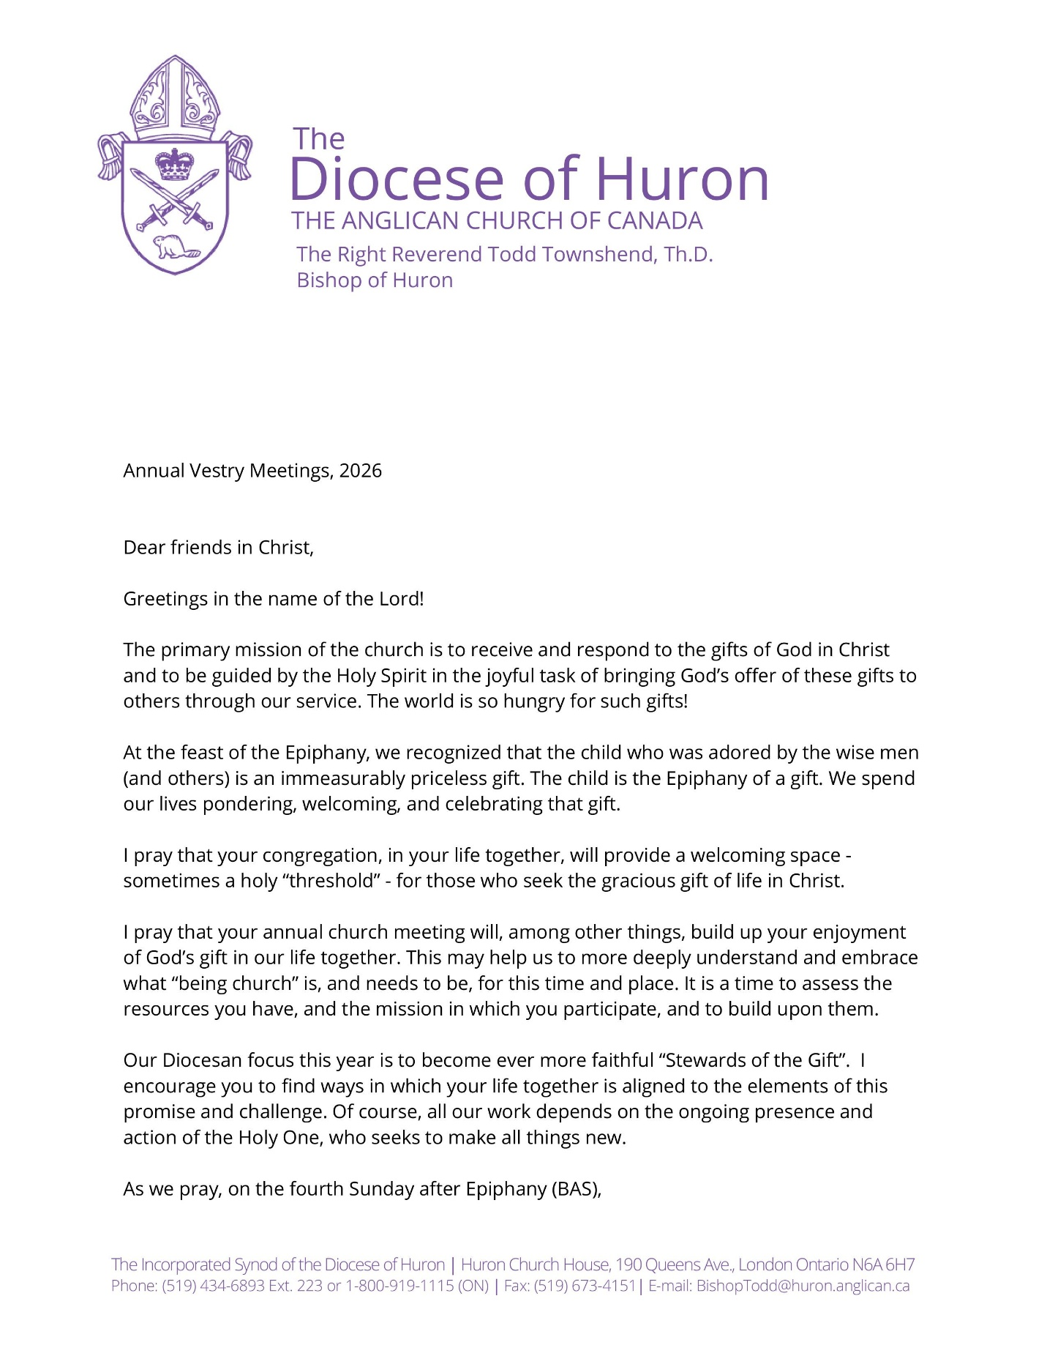

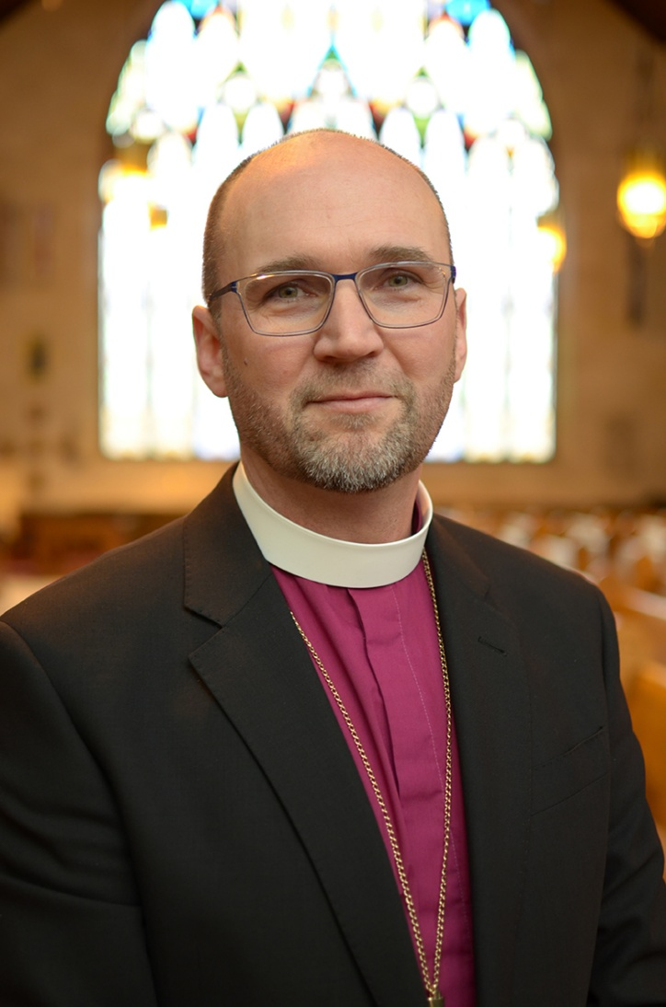
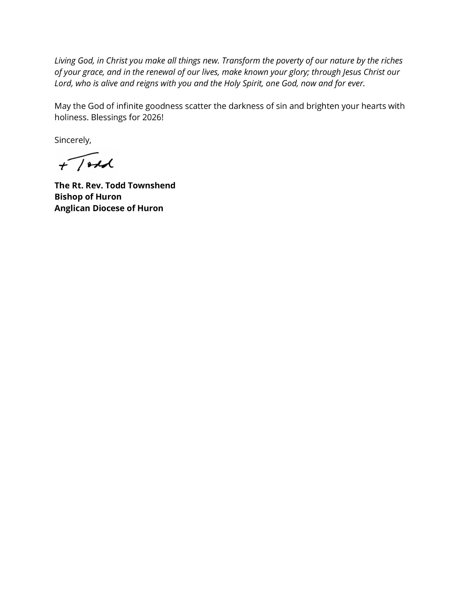

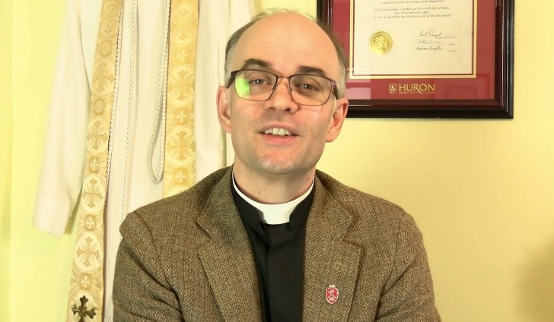
RECTOR’S REPORT

St. George’s, Clarksburg
The Parish of the Blue Mountains
January 17st, 2026

DEEPENING OUR FAITH:
Growing in Our Relationships
I give you a new commandment, that you love one another.
Just as I have loved you, you also should love one another.
By this everyone will know that you are my disciples,
if you have love for one another.”

The Gospel of St. John 13.34-35

There are many types of reputations that churches can have in their communities today. Some are known for their outside architecture, for the appearance of the church building in the community. One online ‘reviewer’ of our own St. George’s commented noted that our church was the “one with all the beautiful flowers” – a lovely way to be remembered in the community!

However, I have come to appreciate, in my years of ministry experience, the reputations of churches that are found, not from outside the building, but rather, on the inside. How are the people inside the building remembered in the wider community? What are they known for? What do they do?

These are the types of questions that Jesus was focused on, when he was departing from his disciples after teaching them for three years during his earthly ministry. The truth is, it was easier to be known by who your people were, and what they did, back in the earliest days of Christian ministry, because of the fact that there were no church buildings to admire! The “Church” was always intended to be those who followed in the footsteps of Jesus.

Jesus was very concerned about the type of reputation that his followers would have.
And so he instructed them to model their own lives, behaviour and habits on the same love that he had shown them. A love that looked beyond differences, imperfections, social constructs, genders and cultural background. A love that saw each and every person as a child of God, and as another potential disciple of Jesus.
Rarely did Jesus issue a commandment in his teaching ministry on earth, but when he did, his followers were quick to listen. In one of Jesus’ most intimate moments with his disciples, when he was teaching them about his upcoming death, he did specifically issue a command for them: “Love one another. Just as I have loved you, you should always love one another. By this everyone will know that you are my disciples, if you have love for one another.”

In this moment, not only was Jesus sharing a gift with his followers, the gift of “loving presence” that they would offer to and for each other, but he was also shaping the Christian identity for generations to come – that Christians should be known in the wider community for the ways that they love others.

In a recent Town of the Blue Mountains Deputation (a meeting held by Town Council in which St. George’s leaders were presenting a new outreach proposal: The Waygate Project), I was able to hear a little bit of the reputation that St. George’s currently holds in our wider neighbourhood and community.

Following an amazing presentation by Michelle Hughes, one of our Diaconal Postulants, the Town Counsellors were able to ask questions or share comments. One mentioned that Town Council often receive presentations about various groups who are “asking for things” from the Town and the community. Quite the opposite, that counsellor mentioned how remarkable it was that St. George’s had come to Town Council to ask permission to “give back” to the community.

What he meant by this was the fact that our future Waygate Outreach Project is all about offering supports to our neighbourhood: clean water for cyclists, walkers and dogs; food in our food cupboard for anyone in need; a prayer mailbox to better respond to the spiritual needs of the neighbourhood; a community announcement board to spread the news of how other groups are supporting our local residents. St. George’s, in our presentation to the Town, wanted to “give back” to the neighbourhood as a living out of our congregational identity: “Caring for Others Because God Cares for Us All.” This, said our Town Counsellor, was so refreshing to hear – an organization that gives instead of always taking.

Other counsellors chimed in to describe the people of St. George’s as “generous”, “hardworking”, “caring”, “innovative”, and “an integral part of the Blue Mountains community”.
In hearing these comments, I have been reflecting on how Jesus must be pleased with our efforts. That the reputation of the people “inside of the church with all the flowers” is that we care, and that our faithfulness in caring extends well beyond the walls of our church building.

Allow me to take a moment to continue to highlight how we have sought to be known through a reputation of love and generosity:
- 2026 saw the installation of St. George’s new pollinator garden, a ministry that not only supports our local environment (the bugs and the bees), but also allows for us to participate in the TBM Pollinator Pathway Project, a network of similar gardens throughout the Blue Mountains. Our garden will be one of the stops along the tour!
- Support for the Beaver Valley Outreach: St. George’s again offered a $1,000 donation towards the annual Christmas hampers that help local families. This donation was on top of many additional ones made in support of BVO programming throughout the year.
- Support for our local service organizations: this year the proceeds from our Community Corn Roast ($1,000) were donated to the Thornbury-Clarksburg Rotary Club, in support of this mission of “service before self”. St. George’s continues to host their monthly meetings, and our Catering Group provides delicious meals for their monthly business meetings. St. George’s also now hosts the annual Royal Canadian Legion Branch 281 Honours and Awards banquet, just another of the ways that we partnership with our local Legion has continued to grow over the years.
- St. George’s has also been recognized by our National Anglican Outreach organization, Alongside Hope, as being one of the most generous congregations in Canada, in our support of Ukraine and Gaza. Over the past two years, we have donated thousands of dollars to various relief and support projects. This Christmas, we received personal thank you notes from Dr. Suhaila Tarazi, Director General of the Ahli Arab Hospital in Gaza and from Zoreslava, the Director of the Dzherelo Centre for Disabled Children in Ukraine.
- Last year’s Pancake Supper also saw a deepening relationship between our Congregation and our Local First Responders (TBM Fire Department, Paramedics and OPP). After serving 250 guests, we raised $3,500 in support of the Boots on the Ground organization which provides mental health supports and counselling for first responders and military personnel.
- Indigenous Ministries: through the generosity of our membership, St. George’s as able to make a $1,000 in support of a Northern Ontario Suicide Prevention Line for Indigenous Communities. This is the second year that we have been able to assist in this important ministry.
- Community Collaborations: St. George’s has proudly expanded our relationships with Grace United Church (through our partnering around summer worship services and choir events), with the Shoreline Chorus (through hosting annual concerts and occasional choir collaborations), with our local Christian congregations (through the annual Good Friday ecumenical services), and with our local artisan groups in our 2025 participation in the Town of the Blue Mountains Art Walk.
- The Generosity of St. George’s ACW in supporting youth ministry at Camp Huron: we give thanks to our Anglican Church Women, for their annual commitment to supporting youth and our diocesan Camp, as they sponsor campers each year through the bursary assistance program. Yet another way our community shares the gift of faith and love with even the youngest generations.
- Through our Diocesan, Provincial and National Church Ministries: For generations, St. George’s has been one of the leading congregations in the Diocese through our support of the wider Church. 1/3 of our apportionment payments each year go to support the infrastructure of the National Church and its support of the Anglican Council of the North. Many of Canada’s northernmost dioceses are subsidized because of the small population sizes in the north. Our contributions allow for clergy to receive stipends in communities that would not be able to afford them.
- In 2026, St. George’s also hosted the Annual Bishop’s Friends North Fundraiser. Together, with parishioners from other congregations in the Deanery of the Saugeens, we raised $5,703.34 in support of the Bishop of Huron’s Discretionary Fund, used to support clergy and families in times of emergency.
It is truly remarkable to consider the impact that living out a reputation of love and generosity can mean not only within our St. George’s family of faith, but also to those we share it with.

This summary of our community engagement is even further expanded when we consider the reach of our pastoral ministries to include the 480 people who were cared for through funeral ministries and the 192 guests at weddings this year. In total, St. George’s cared for more than 8,400 people in 2025: through palliative visits at bedsides, through 52 weeks of worship services, in small group gatherings and in large community events. As your priest, it has been a privilege to walk with you through all of these pastoral engagements. Wherever God calls us to service, there we have tried to live into the reputation of “love one another.”

As we have entered into this 2026 year, the theme and focus of our leadership strategy will be on Deepening our Faith and Growing in our Relationships. What do I mean by this? Continuing to live into the reputation of “loving one another” as Jesus has commanded us to do, this year will have a particular focus on how St. George’s relates to one another and those in our neighbourhood. We hope to do this in three ways:

- A Renewed Focus on Pastoral Care: St. George’s in just beginning a process of setting up a new “Pastoral Care Office”. Situated in the former Youth Ministry Room, this new office will be the home for our Diaconal Postulants and our Associate Priest. In the weeks ahead this office will be painted, newly furnished and set up with both office space, equipment and phone lines, and a small pastoral visitation seating area. Any pastoral concerns in the parish (request for visits, pastoral emergencies, prayer requests or inquiries about our St. George’s ministries) will be directed through our Pastoral Assistant, Donna Whiteside, who will be available in the mornings, Tues-Thurs, will be responded to by Donna. Donna will then be coordinating with our priests to help us increase the monthly contact between our pastoral leaders and all the membership of our parish. Should you ever desire a cup of coffee with either of our two priests, or with Donna, please don’t hesitate to reach out to the office: parishofthebluemountains@gmail.com or by calling (519) 599-3047.

- Greater Opportunities for Biblical Learning and Spiritual Exploration: One of the ways to deepen our faith is to draw closer to God through daily routines of prayer or Bible Study. Starting off with a Lenten series on the Book of Revelation, I hope to share more of my teaching ministry with the congregation in this next year. Some of these studies will be partnered with our sister church, Christ Church in Meaford, to respond to requests that I have received to dig deeper into our knowledge of the Bible and into our identity as Anglicans.
As we enter into the Season of Lent, should there be any member of our parish who has not yet been confirmed in their Christian faith as an Anglican, please don’t hesitate to reach out to me. I would be very eager to create a study program tailored for your needs, and present an opportunity to be confirmed by our Bishop at a service coming up in the Spring. Curious about exploring more, email me at: grayhamebowcott@diohuron.org

- Expressing our Love of Others Through Caring for the Community: The final area of focus that St. George’s will be celebrating this year will be the launch of our new WAYGATE Outreach Parkette. This project, which has been part of the diaconal ministry of Michelle Hughes, will see the addition of a new water fountain, community food cupboard, community prayer box, and more! It will also see the expansion of our communication abilities with the construction of a new church sign along Marsh Street. I am pleased to confirm that Michelle Hughes will be sharing a ten minute presentation on this project at our February 8th Vestry Meeting. Come the Spring, this project will “spring up” very quickly. We are pleased to share that, while there may still be some donor/naming opportunities possible, this project is projected to be fully funded before we even put a shovel in the ground! Again, I want to say thank you to Michelle for her hours of research, application writing and presentations to make this Community Caring Hub a possibility!
By way of closing this 2026 Rector’s Report, I want to say how much of a privilege it is to experience the flourishing of our community reputation, as being known by the way that we love others. I am deeply grateful for each and every one of our members who support our ministries: through their dedication and participation, through the sharing of their own personal gifts, and through their financial support.

My hope for all our members, is that we recognize how our collective efforts in faithfulness, through our worship, our volunteering, and our reaching out to others, is a direct living out of the commandment of Jesus: love one another. Here at St. George’s, we don’t just believe this, we live it out in full and transformative ways.

May God continue to bless St. George’s as we follow in the footsteps of his son, Jesus.

Blessings in our shared journey of faith,


Faithfully submitted by The Rev’d Canon Dr. Grayhame Bowcott
Rector, serving St. George’s, The Anglican Parish of The Blue Mountains

DIRECTOR OF MUSIC MINISTRY’S REPORT
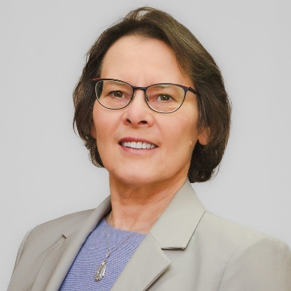
This was a busy year for our choir!

Along with the 10:00 am services’ hymns, psalms, settings and anthems, and a few funerals, 2025 was a year of alliance with our friends at Grace United Church. The two choirs combined to present special music for Good Friday (Apr.18 at BMCC), Ascension (May 29 at GUC), Remembrance Sunday (Nov.9 at St. G.’s), and CarolFest (Dec. 14 at GUC). Also, during the summer when we usually have a break, we prepared anthems for 3 of the combined services.
This collaboration has been a boost for both groups as we share our traditions and enjoy full harmony.

Considering that Common Praise hymnal is now more than 25 years old, congregational music is supplemented by Sing A New Creation (2022) and songs available through music licenses. In January, the Jones’ Parish Mass setting of service music was introduced; the Mass of Angel and Saints, a gem found in the music library, was initiated for Advent. Now we can choose from at least 6 different settings of service music for Eucharist. A big snowfall kept me at home one Sunday in Feb., but the music continued a capella that morning; all was quiet during a major power failure / ice storm in March.

Instrumental guests: Lent 2- Andrew Wilson accompanied on guitar for a song by (Bishop) Gordon Light; Palm Sunday - Rev. Bowcott’s daughter Alyvia made her debut with a flute solo; Remembrance Sunday -Eobhann Bruce played on the small-pipes for the Gradual.
The pipe organ has no operating concerns; a digital piano in the lower hall, now considered St. George’s instrument, has been in use for lessons and occasional events. A new feature at 8:00 a.m. services this year is to have a piece of recorded music playing during communion - usually the same will be used later at 10:00 a.m.

Services at Errinrung LTC continue monthly (4th Mondays) - helpers not only from choir have been attending, and others are welcome. We are reassured by the participation of the residents who look forward to being at these gatherings. A Remembrance service on Nov. 16 included members of RCL 281 and Mayor Matrosovs, but two other scheduled services had to be cancelled due to outbreaks, including the favourite Christmas carolling service.

Early in the year we celebrated the music-filled lives of two devoted soprano choristers, Gail Rows and Frances Murray. Gail and Frances were long-time friends too, who passed into God’s peace only a few weeks apart.

Closing out 2025, despite stormy days and ‘flu, CarolFest and Shoreline Chorus’ Christmas concert at St. George’s gave us the opportunity to present two contemporary anthems. Christmas Eve had carols sung by energetic congregations, and an opportunity to test out a carol mash-up (originally planned for 2022 when a big storm came instead) - seeing lots of smiling singers meant it must have worked.

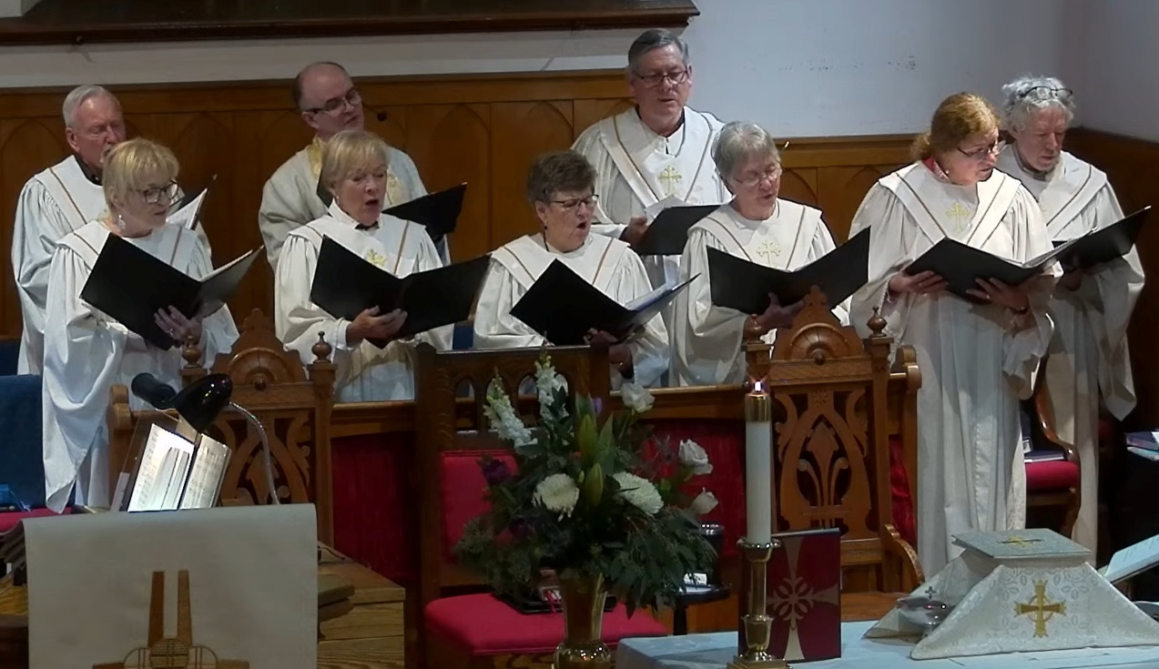

Choir rehearsals are on Wednesday afternoons from 1:00 p.m. -2:30 p.m. Thank you to each of the singers of St. George’s choir, you who “sing and make music from your heart to the Lord” (Eph. 5:19) - for your time and dedication. An invitation is always extended to anyone who has an interest in joining us in this active ministry of music.

Respectfully submitted,
Janet Cringle (Director of Music)

A REPORT FROM OUR
HONOURARY ASSOCIATE PRIEST
The Venerable Judy Walton

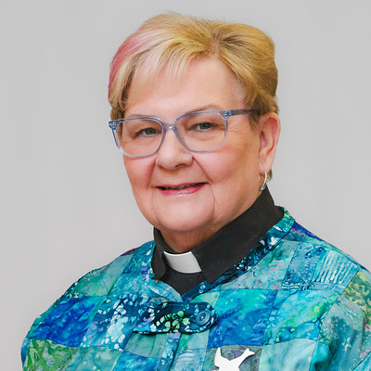

Dear Friends,

As I reflect on the past year, I am filled with deep appreciation for the time we have shared together as a church family. This period has been marked by a strong sense of community, mutual support, and a profound awareness of God's grace in our midst.

Leadership and Gratitude

This year has been exceptionally productive, thanks in large part to the steadfast dedication and leadership of Canon Dr. Gray Bowcott. His tireless commitment has guided our parish, and we are truly blessed to have him serve as our parish priest.

Mentoring and Spiritual Formation

In my capacity as Associate Priest at St. George’s, I have had the privilege of working with our two deaconate postulants, Donna Whiteside and Michelle Hughes. We meet individually for Spiritual Direction and gather jointly to discuss their progress, experiences, and the ways they perceive God’s presence in their formation. These sessions are sometimes dedicated to teaching, while at other times, they offer encouragement as Donna and Michelle work towards their goal of becoming deacons for the Diocese of Huron.

Counselling and Support

Alongside my work with the postulants, I continue to provide Counselling and Spiritual Direction to parish members who seek guidance. It is an honour to use my skills to support individuals as they navigate life's challenges, offering discernment and a compassionate ear whenever needed. Please feel welcome to reach out to me for confidential, non-judgemental support.

Pastoral Space Improvements

These sessions have traditionally taken place in my home, offering a private and comfortable environment. However, I am eagerly anticipating the move to our new pastoral office, which will be located in the space formerly used as the Sunday School room. We are currently selecting paint colours and furniture for the room, which will soon provide a quiet and private setting for pastoral work.

Ministry and Sacraments

Being a member of the ministry team brings me great joy. I am always thankful for the opportunity to minister the Sacrament of Healing and Anointing on the last Sunday of each month. Additionally, Canon Gray has entrusted me with several opportunities to celebrate the Eucharist and to preach, which has enabled me to fulfil my priestly vows and deepen my commitment to our parish community.

It has been my privilege to walk alongside you over the past church year. May God continue to bless us as we journey forward together.

Blessings,

Judy Walton

Emeritus Archdeacon

REPORTS FROM OUR
DIACONAL POSTULANTS

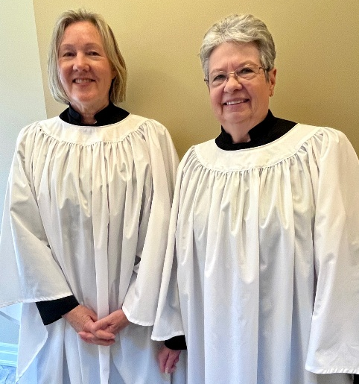

From Michelle Hughes

It has been just one year since beginning this period of Diaconal Postulancy, a period of education, training and discernment. Firstly, I am so grateful to Bishop Todd, our Diocese of Huron, Canon Gray, Archdeacon Judy, Donna Whiteside, my support team and all of you for this opportunity to serve our beloved St. George’s in a way that has given so much joy and many opportunities for growth over the past year.

This past year has involved much learning. I am presently taking classes through Huron College’s, Licentiate in Theology (LTH) program, led by Canon Gray, working toward a certificate in Diaconal Ministries. There is also an expectation of daily prayer and continued study of God’s Word. This is a blessing.

We are also blessed as Diaconal Postulants to serve in Liturgy. There has been much to learn, in assistance to our Priest, in Proclaiming the Gospel and serving at the Altar. I am grateful to God to share in our worship service. Thanks to all for your helpful comments, encouragement, and at times, loving patience.

I have been exploring a call to serve St. George’s within Outreach to our greater community. One description of a Deacon (there are several) is to act as a bridge between the world and the church, having one foot in the church and one foot in the community beyond the doors. A bridge is really a connector, a place to travel back and forth, joining one side to the other. It is a Ministry of Service, bringing the needs and concerns of the community to the church and helping to organize to meet them.

St. George’s has a huge heart for outreach, historical, well known and recognized. We, as a body, live out our mission of making Christ and his redemptive love known in our actions of service to others, in “Caring for others because God cares for us all”. We have many exemplary leaders within our Outreach Ministry. It is important to stay in touch with the needs of our greater community, to listen to their concerns and respond in service. My role is to be a helper, connecting those in need and those other caring groups to St. George’s. It’s all about our relationships.

Much of my service, happens outside the walls. Bishop Todd described the role of Clergy (Bishops, Priests and Deacons) as living out the diakonia (Ministry of Service) to which all of us are called in our Baptism (Laity), although perhaps from a more integrated level. This past year has been a continuation of service alongside other care groups and leaders, in our greater community of the Blue Mountains. I am blessed to serve in areas that help others in need, with children, seniors, with those living with disabilities and within creation care.

Our relationship to God’s Creation, is part of our Baptismal Covenant, we have a role to safeguard creation. Our little pollinator garden has brought some joy to community groups within our Parish Hall, gazing out the window. Many thanks to the dozen plus volunteers who helped dig out, clear, plant and tend. It’s a beautiful garden and a small step in supporting our essential pollinators in decline. The Town of Blue Mountains Pollinator Group, who were so helpful and generous to support us and create the garden design have asked St. George’s to be part of a Pollinator Pathway which will be available to all Town residents and visitors.
St. George’s has wonderful relationships with other service organizations and helpers in the Town of the Blue Mountains. This past year we’ve been continuing to grow in our relationships, as we serve alongside together.

Our upcoming “WAYGATE Project” has been well embraced by our greater Diocese. St. George’s is presently awaiting outcome of an Anglican Foundation Grant application for funding. We have received letters of support from both our Bishop Todd and Archdeacon Tanya. In community, we have been meeting and looping with other service leaders (Rotary, BVO, High School, Library) and local contractors, sharing plans with them and partnering together as we move forward with implementation of the various elements of care.

End of year, it was an honour to represent St George’s at Town Council in presentation of our WAYGATE Project. It was a very proud moment to be a part of such a generous offering toward our extended community and to see the smiles and hear the words of praise for our St. George’s, for what we are doing and for what we have done. Kindness, generosity and neighbourliness were used in description. You are all a part of that, as are those who came before us, who served our church so well.

Since our meeting with Council, St. Georges has received confirmation from Town for a Community Improvement Grant of $10,000 toward our WAYGATE Project.

In our welcoming prayer, we often pray for the guests which God brings to St. George’s, that they feel embraced, served and loved by our church. I must share that in serving you all, in your encouraging words, in your emails of support, in your presence at our meeting, in your kindness and happiness, there was an overwhelming sense of experiencing what we pray for together on Sunday. There is no better affirmation than the love of God we share together.

Faithfully submitted,

Michelle Hughes, Postulant for Diaconal Ministry in the Diocese of Huron

From Donna Whiteside

It is hard to believe that a year has come and gone since we, Michelle Hughes and I, were accepted by Bishop Todd Townshend as Postulants in the Diocese of Huron on December 18th, 2024. Although we are separated through our disparate directional ministries as Diaconal Postulants, our support of each other is very strong and a true comfort.

As is always the case, when we are busy, time flies. This past year has been a busy one, filled with LTh courses, studying, participating in the weekly congregational services at St. George’s and the Errinrung services held on a monthly basis. We attended an ordination in London, a Fall Retreat in Essex and participated in the Synod Opening Service at St. Paul’s Cathedral in London. My journey has taken me to hospital beds and homes to offer Communion and pastoral visits. My prayer life continues with the Sunday Prayers of the People, as well as an executive role with the Diocesan Anglican Fellowship of Prayer. As I have mentioned in previous reports, the two highlights of this past year for me were receiving the beautiful vestments on Palm Sunday from the generosity of St. George’s and serving at a beautiful Eucharistic Service with Bishop Todd Townshend and Michelle, here at St. George’s with the clergy of the Deanery of the Saugeens present.

This journey could not be possible without the love and support that I have received from the members of St. George’s, the encouragement of my support group, the spiritual direction from Archdeacon Judy and guidance from Rev. Gray and the close relationship I have with Michelle. I am deeply indebted to each of you for giving me the confidence to believe that I could very well become a Deacon.

Looking forward to 2026, there are many learning adventures that lie ahead. Stay tuned as we venture through this next year together.

Submitted with Love & Thanksgiving

By Donna Whiteside

PASTORAL STATISTICS REPORT 2025

Baptisms: 0

Confirmations: 0

Marriages: 3 Christopher Labatt Ross to Sara Florinda da Silva Matthew James Anderson to Regeena Angeles
Cullen Nissen to Gabriella Zawadzka

Funerals: 9 Frances Jeanne Murray
Gail Ann Rows
John Sage
John Hellier
George Alexander Hamilton
Gail Joan Whitbeck
Ronald William George Cox
Catherine Antoinette Sinclair
James Martin Kerst

Scattering of Ashes 4 Gail Joan Whitbeck
Catherine Antoinette Sinclair
Nan Victoria Maitland (d. 2020)
James Martin Kerst



REQUIESCAT IN PACE

Priest: Let us pray.

God of unimaginable love and mercy,
Into your hands have we delivered these your faithful servants.

May you be ever present to their families and loved ones.
In their grief and their loss, draw them closer to you.

Make us ever mindful of the ways that we can be a comforting presence to them.
And lastly, Lord in your love,

All: May all the souls of the faithful departed rest in peace
and rise again in the glory of Jesus Christ Your Son.

Priest: In the Name of the Father, Son and Holy Spirit.

All: AMEN

Annual Statistic Report for 2025

Deanery: The Saugeens

Congregation: St. George’s Town/City: The Blue Mountains

1. Baptized Persons 302 10. Baptisms 0
On Parish Roll (see Note:1.)

2. Identifiable Givers 197 11. Confirmations 0
to Parish Funds

NOTE: FOR ATTENDANCE FIGURES, SEE ATTACHED ATTENDANCE/ENGAGEMENT REPORT

3. Weekly Attendance 154 participants 12. Received from 0
(see Note:2.) Other Communions

4. Sunday Attendance 99 participants 13. Marriages 3
(see Note:3.) (2 Offsite)

5. Easter 325 participants 14. Funerals 9
Attendance (see Note:4.)

6. Do you regularly conduct 15. Youth Music Leaders
worship services in and volunteers 2
institutions? Yes

If so, how many in 16. Youth Choir 4
attendance per month 28
(see Note:6.)
7. Christmas 478 participants 17. Youth Drop-in 17
Attendance (see Note:5.) BVO partnership
(see Note:7.)
** 8. Pentecost Sunday 135 participants

** 9. 2nd Sunday in Sept. 94 participants

** New attendance Sundays required (for 2013) in order to comply with General Synod (GS) average attendance figures from Dioceses required in determination of future General Synod (GS) delegates, as per GS Resolution, 2013.

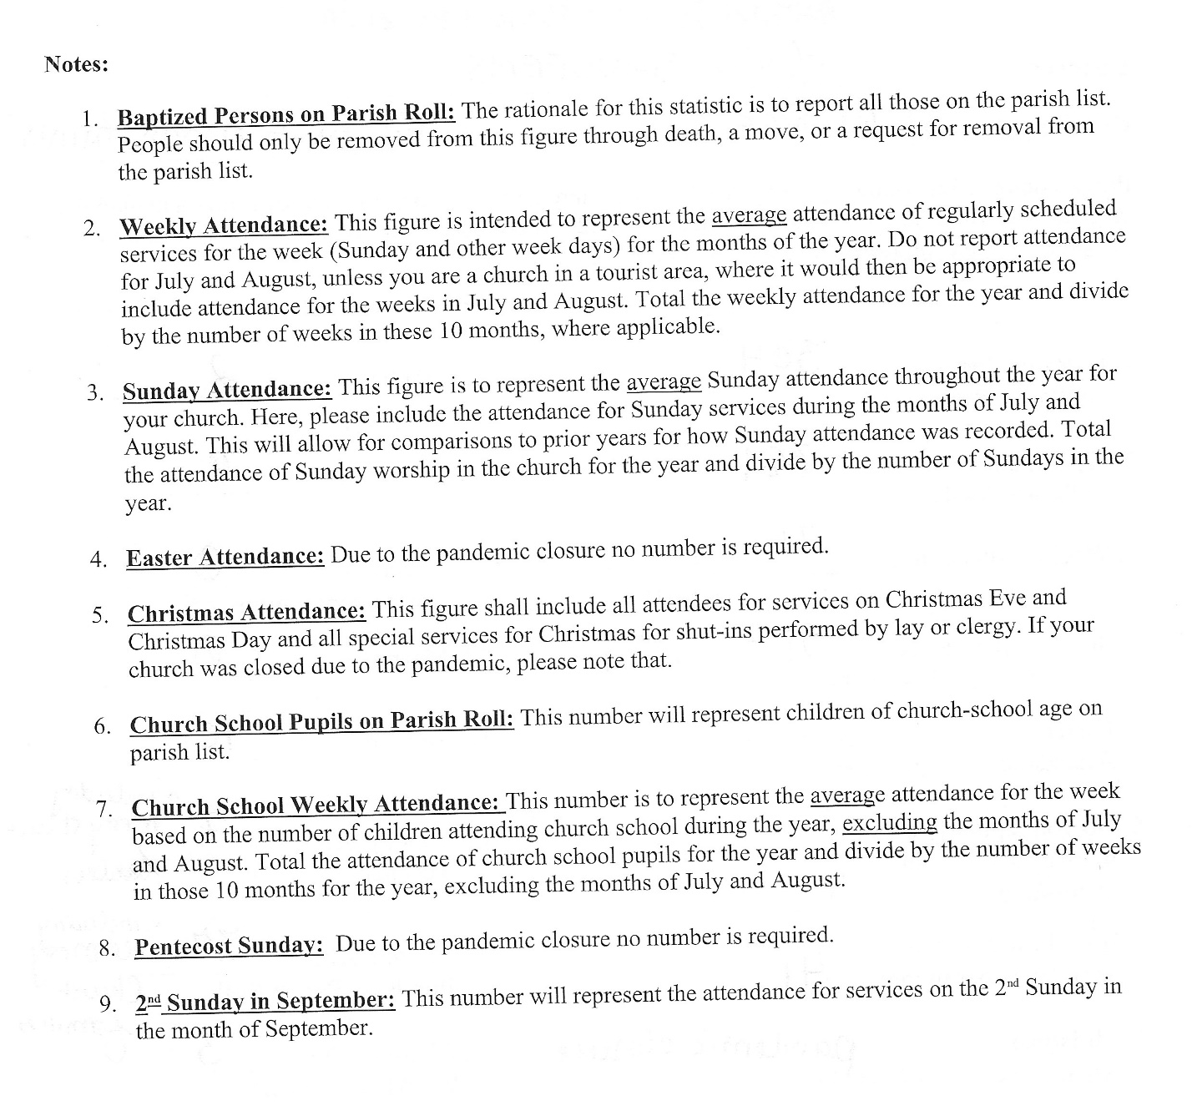

WORSHIP PARTICIPANT REPORT – 2025 REVIEW

Statistical Report of Worship Services for St. George's, The Parish of The Blue Mountains - The 2025 Year
WORSHIP PARTICIPATION STATISTICS - St. George's TBM 2025

Sunday | 8:00 AM | 10:00 AM | Online | Midweek | Sunday Total | Weekly Total | Notes:
Epiphany - Jan 5th | 15 | 37 | 69 | 11 | 121 | 132
Baptism OTL - Jan 12th | 25 | 50 | 34 | 0 | 109 | 109
Jan 19th | 21 | 44 | 42 | 5 | 107 | 112
Jan 26th | 19 | 37 | 45 | 50 | 101 | 146
Feb 2nd | 19 | 47 | 29 | 18 | 95 | 113 | VESTRY
Feb 9th | 18 | 28 | 41 | 15 | 87 | 102
Feb 16th | 15 | 19 | 51 | 10 | 85 | 95 | Snowstorm
Feb 23rd | 18 | 31 | 42 | 4 | 91 | 95
Transfig - March 2nd | 15 | 27 | 32 | 39 | 74 | 113 | Snowstorm
Lent 1 - Mar 9th | 15 | 38 | 43 | 24 | 96 | 120
Lent 2 - Mar 16th | 17 | 39 | 43 | 14 | 99 | 113
Lent 3 - Mar 23rd | 13 | 33 | 118 | 37 | 164 | 201 | Memorial Eucharist for Frances Murray
Lent 4 - CANCELLED | 0 | 0 | 0 | 40 | 0 | 40 | Snowstorm and Power Outage
Lent 5 - Apr 6th | 26 | 39 | 39 | 18 | 104 | 122
Psalm S. Apr 13th | 26 | 54 | 68 | 208 | 148 | 356 | Holy Week
Easter - Apr 20th | 45 | 91 | 44 | 229 | 180 | 409 | EASTER SERVICES
Apr 28th | 0 | 0 | 0 | 27 | 0 | 27 | Errinrung Easter
Easter 2 - Apr 27th | 25 | 46 | 32 | 12 | 103 | 115
Easter 3 - May 4th | 25 | 39 | 16 | 4 | 80 | 84
Easter 4 - May 11th | 21 | 35 | 39 | 7 | 95 | 102
Easter 5 - May 18th | 21 | 38 | 28 | 5 | 87 | 92
Easter 6 - May 25th | 29 | 42 | 38 | 94 | 109 | 203 | Ascension Service
Jerusal - Jun 1st | 22 | 37 | 31 | 8 | 90 | 98
Pentecost - Jun 8th | 19 | 42 | 74 | 31 | 135 | 166
Trinity - Jun 15th | 25 | 49 | 29 | 15 | 103 | 118
Corpus C - Jun 22nd | 23 | 30 | 15 | 26 | 68 | 94 | Post Fish Fry
Peter & Paul - Jun 29th | 22 | 30 | 19 | 11 | 71 | 82
Pent 4 - July 6th | 20 | 70 | 33 | 2 | 123 | 125 | With Grace
Aug 17th | 25 | 71 | 29 | 4 | 125 | 129 | With Grace
Aug 24th | 26 | 63 | 35 | 20 | 124 | 144 | With Grace
Aug 31st | 20 | 85 | 92 | 7 | 197 | 204 | With Grace
Sep 7th | 20 | 36 | 30 | 14 | 86 | 100
Sep 14th | 19 | 41 | 34 | 16 | 94 | 110
Sep 21st | 24 | 44 | 35 | 51 | 103 | 154 | Errinrung Thanksgiving
Sep 28th | 26 | 53 | 13 | 70 | 92 | 162 | Bishop's Friends
Oct 5th | 18 | 36 | 41 | 17 | 95 | 112
Thanksgiving 1 - Oct 12 | 34 | 40 | 39 | 12 | 113 | 125
Thanksgiving 2 - Oct 19 | 19 | 47 | 19 | 21 | 85 | 106
Oct 26th | 22 | 43 | 29 | 44 | 94 | 138
All Souls - Nov 2 | 21 | 34 | 33 | 59 | 88 | 147 | Guiding Service
Remembrance - Nov 9 | 11 | 98 | 71 | 875 | 180 | 946 | Remembrance Services x7
Nov 16th | 23 | 37 | 29 | 51 | 89 | 140 | Errinrung Remembrance
Reign of Christ - Nov 23 | 24 | 45 | 22 | 3 | 91 | 94
Advent 1 - Nov 30th | 25 | 34 | 39 | 200 | 98 | 298 | Clarksburg Christmas
Advent 2 - Dec 7th | 23 | 53 | 16 | 31 | 92 | 123
Advent 3 - Dec 14th | 12 | 123 | 27 | 35 | 135 | 170 | Snowstorm + Carolfest
Advent 4 - Dec 21 | 32 | 35 | 76 | 394 | 143 | 537 | All Christmas Services
Christmas 1 - Dec 28th | 20 | 35 | 23 | 0 | 78 | 78
TOTALS | 1003 | 2125 | 1826 | 2888 | 4927 | 7701
Sunday | 8:00 AM | 10:00 AM | Online | Midweek | Sunday Total | Weekly Total | Notes:
Average 8:00 a.m. Engagement |  |  | 20 people per Sunday
Average 10:00 a.m. Engagement |  |  | 43 people per Sunday
Average Sunday Online Engagement |  |  | 37 people per Sunday
Average Sunday Engagement (all sources) |  |  | 99 people per Sunday
Average Mid-week Engagement |  |  | 55 people per week
Average Weekly (all services) Engagement |  |  | 154 people per week
Funeral services: |  |  | Marriage:
Rows | 120 |  | Ross & DaSilva |  | 32
Murray | 127 |  | Angeles & Anderson 160
Hamilton | 24 |  | Total |  | 192
Whitbeck | 7
Cox | 68
Sinclair | 92
Kerst | 42
Total | 480
ATTENDANCE/ENGAGEMENT REPORT

Average attendance at the 8:00 a.m. service (52 weeks) = 20 people.
Average attendance at the 10:00 a.m. service (52 weeks) = 43 people
Average engagement (online) of the 10:00 a.m. service (52 weeks) = 37 people.
Combined (in-person and virtual) engagement for Sunday worship services = 99 people.
Total Midweek Attendance (non-Sunday services) = 55 participants.

Combined (in-person and virtual) engagement for total weekly attendance = 154 people per week.

Total attendance from Funerals = 480 people
Total attendance from Weddings = 192 people
Total attendance from Remembrance Day Services + Cenotaph Dedication Service = 1,223 people (8 Remembrance Services).

Total attendance from Christmas Services (includes Carolfest, Errinrung Christmas, Christmas Eve and Day (in-person and virtual) = 478 participants

Total attendance from Easter Services (Includes Good Friday) = 325 in-person participants + virtual participants.

Total attendance at all religious services for the Year 2025 = 8,373 participants.

WARDENS’ REPORT FOR 2025


2025 was another EPIC year for the St. George’s Community!

The annual events that are supported by the congregation which ensure the continued success of our various fundraisers are as follows:
- The Shrove Tuesday Community Pancake Supper, hosted in partnership with the Town of the Blue Mountains Fire Department enabled us to raise over $3,500 in support of Boots on the Ground, First Responder Counselling services.
- The 3rd Annual Boot Sale, run by the ACW, allows for parishioners to sell their wares (a community yard sale), while also producing revenue for our Women’s Group and the ministries that they support. A big thank you to the Thornbury-Clarksburg Lions Club for making their delicious Peameal on a Bun!
- Thank you to all those who volunteered and supported our 2025 Plant Sale, organized through the leadership efforts of Hazel de Burgh and John Hethrington. It was another successful year, bringing together gardeners from the community while also raising significant funds for our ministries.
- The Garden Party Fish Fry: even though the attendance in 2025 was slightly down, as a result of the prediction of stormy weather, it continued to be a cherished community event hosted by the whole St. George’s family. Our hands-on-deck volunteers do an amazing job of serving hundreds of guests and continuing in the great tradition of hospitality to our neighbourhood.
- The Community Corn Roast: it was a very hot day for the Corn Roast this year, which meant that most our guests looked for the shade of the trees along our greenspace. We are grateful for the support of the community who helped us to raise $1,000 which was then donated to the Thornbury-Clarksburg Rotary Club.
- The ACW Christmas Bazaar was incredibly well attended this year, with record seatings for the lunch that was served. Our customers left with their hands full of cookie trays, baked goods and full tummies!
- A special Thank-You to the Grace United Church Green Team, who generously partners with us in many of our community events to raise environmental awareness and help reduce our environmental impact. Their clean up at large events also lightens the load of our volunteers.
- This year we hosted the 2025 Bishop’s Friends North Dinner for the Deanery of the Saugeens. This event draws participants from the various congregations within our Deanery for a time of fellowship, and an opportunity to raise financial resources for the Bishop’s Discretionary Fund. This Fund is used to assist clergy and families during times of emergency or distress. 60 guests sat down to enjoy a musical interlude featuring Ann-Marie MacDairmid (on piano) and Karen James (on flute) before an amazing gourmet meal of Prime Rib, root vegetables and local pies. After the dinner, a silent auction was held for gifts cards from local Grey/Bruce restaurants.
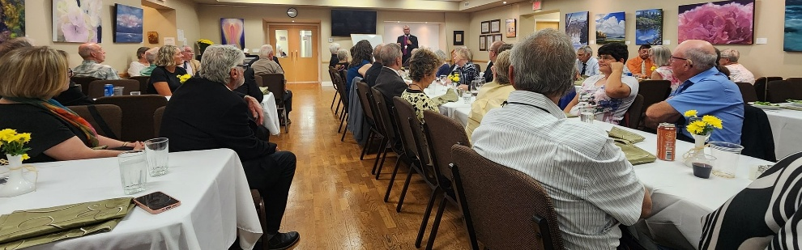
One of the highlights of 2025 was our shared services with Grace United Church, as their minister, The Rev. John Smith, was nearing the end of his ministry contract. Combining congregations over the summer months allowed for full services and the sharing of music ministry between our two choirs and choir directors. This brought great joy to both congregations and provided support when our clergy were on their summer holidays. We may explore a similar summer arrangement in 2026.

St. George’s is exceptionally proud of our own Diaconal Postulants, Donna Whiteside and Michelle Hughes, who have been continuing in their theological studies in Huron University’s Licentiate in Theology program. Please continue to uphold them in prayer as their ministry formation process continues! We are very fortunate to have these two women step into their future roles as Church deacons in our congregation.

Continuing in the Legacy of St. George’s raising up ministry leaders for the Church, this year saw the ordination of our very own The Rev. Father Bryan Kenwell in the Anglican Diocese of Qu’Appelle. Bryan+ also shared the exciting news that he is engaged to be married to Jennifer Wells. Canon Gray has been asked to be one of Bryan’s groomsmen at the upcoming wedding in October 2026!

Lastly, we want to thank the overwhelming support and generosity of our parishioners and community friends who made 2025 an EPIC year of ministry, social events and support for our various community partners. We are blessed to have a close-knit family of faith at St. George’s, and it is only through our wonderful membership that we are able to accomplish all of these ministries.

We give thanks for our 2025 Team of Wardens, for their guidance and support.

A great year, with a great team!

Yours in faith,
Adele James, Bryan Blackie, Caroline Bacher, Sharon Wigle, Gloria Andrews and Tom Kern

MINISTRY COMMITTEE & GROUP REPORTS

GARDEN OF REMEMBRANCE REPORT 2025

Our Garden of Remembrance was dedicated in 2001 for the scattering of ashes with perpetual care. Of note, this year we reviewed the drawings from the original application to create the scattering garden and have determined that the gardens included in the legal definition of the “cemetery” are larger than has been reported in the past. These include the garden space that runs all the way to the south border of the front entrance gate to the church. This means that we have a greater variety of locations for ashes to be scattered for future services.

In 2025, there were numerous donations made to the Garden of Remembrance Endowment. These donations have been invested with the Diocese of Huron for the perpetual care, and the regular maintenance, of this beautiful burial space.

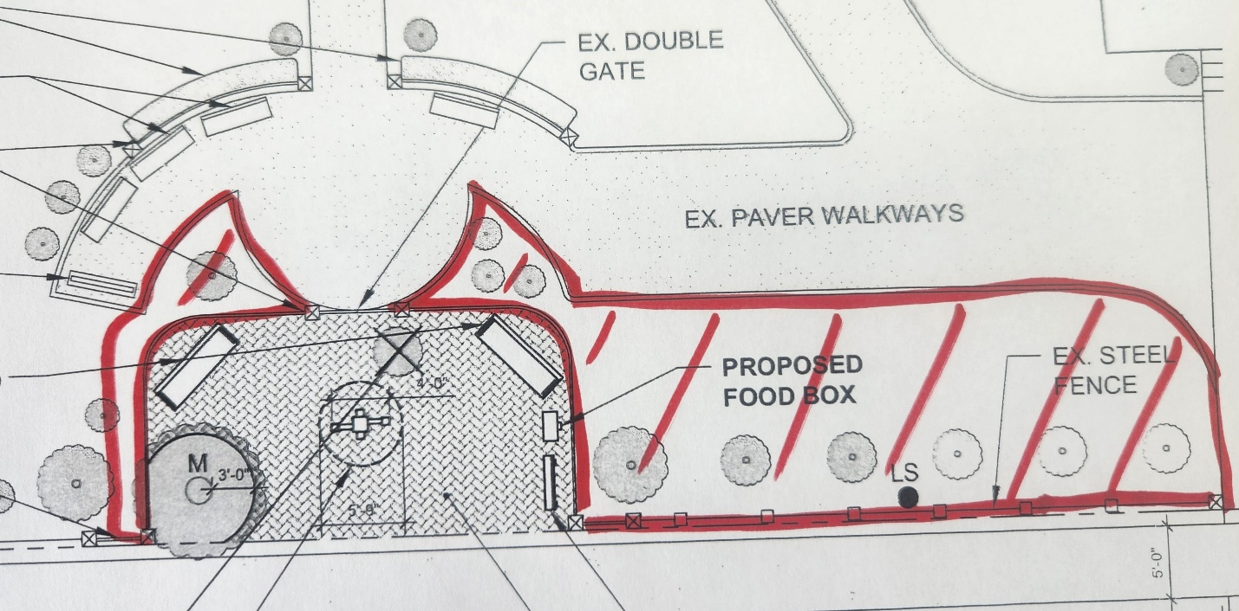

The Garden requires care during the Spring to Fall seasons with planting of annuals, weeding, trimming and replacing shrubs and perennials as necessary. In 2024 we added the Garden of Remembrance Monument that lists past loved ones by their first initials and last name, year of birth and year of passing.

To help with the Garden maintenance, we offer two burial fees: One is a payment of $500 for the Scattering of Ashes service. This mandatory fee is invested towards the perpetual maintenance of the Garden. A second optional fee is for $1,000 to cover the cost of having a name inscribed on the Monument. As of 2025, we have begun making pre-arrangements (and pre-payments) for future burial plans. Should you wish to make future arrangements, please contact Canon Gray, who will share the details with you.

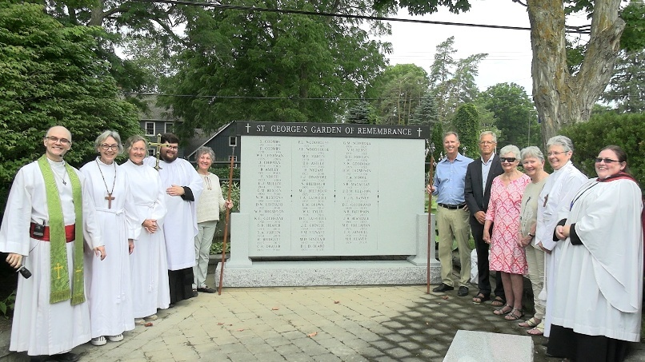

Each scattering is recorded in the Parish’s Register of Burials by the officiating Clergy. There is also a Commemorative Book in the Church vestibule that may be viewed when the Church is open or by calling the Parish Office. As of the time of reporting, there were 4 scatterings of ashes that had taken place for January 1 – December 31, 2025 (for a total since inception of 53). You are invited to consider the Garden for any of its intended purposes.

We are also pleased to report a significant investment increase (of over $20,000) to our Garden of Remembrance Endowment in 2025. This includes both fees and donations. As of November 30th, 2025, the endowment balance was: $40,344.47. It should also be noted that in December of 2025, an addition $2,000 was investment that is not reflected in the previous balance.

The Garden of Remembrance Committee is comprised of the following Trustees: The Chair – Jim Moore; The Rector – Canon Gray; and the four Wardens of the Church (in 2025 – Adele James, Brian Blackie, Caroline Bacher and Sharon Wigle).

We wish to thank professional gardener Anne Fisher and also Bruce Whiteside and several of our parishioners for keeping the grounds looking attractive and inviting.

Respectfully submitted, Jim Moore, Trustee & Chair of the Garden of Remembrance Committee

REPORT FROM DIOCESE OF HURON SYNOD 2025

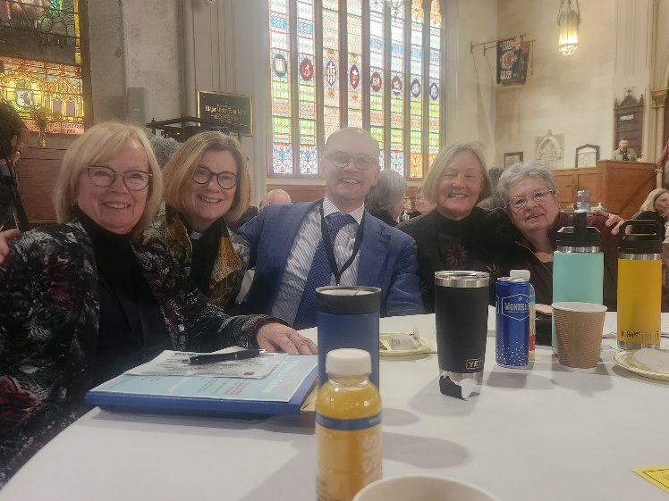

The central theme of the 186th Synod of the Diocese of Huron was “Stewards of The Gift”, held at St. Paul’s Cathedral on October 24th – 25th, 2025.

The stunning, new, totally open design of the Sanctuary at St. Paul’s Cathedral offered a new approach to the seating arrangement for the opening Holy Eucharist service on Friday evening, with Bishop Todd Townshend officiating. The chairs were placed to form a large circle with five distinct sections, representing the four Deaneries of Huron (North, East, South and West), and the fifth section to seat the honorary, legal and governing heads of clergy. A lovely reception followed the service.

Early Saturday morning, the 186th Synod was Called to Order. A quorum was declared with 87 clergy and 137 lay delegates registered.

Bishop Townshend delivered his sixth Charge to Synod “Stewards of The Gift”. After sharing a brief summary of previous charges to Synod, Bishop Todd addressed the theme of stewardship, and to do this by focusing first on “The Gift”. He encouraged us to use the next twelve months to cultivate a life of stewardship and generosity in community, reminding us that we do not preach generosity and stewardship to sustain the church, but rather, for the sake of the world that God so loves.

The bishop continued to express that the existence of the church is essential, that we are the people God will use to transform and reconcile both people and communities to live and share in the abundant life as responsible and joyful stewards of God’s generosity. We are the stewards of the promise of Jesus and his resurrection life. In a time of rampant consumerism, unbridled greed and increasing income inequality, this is the opportune time to allow God’s gift of goodness within us to overflow to the benefit of the broader community and the world.

Following the Bishop’s Charge to Synod, the Financial Report was given with the good news that an audit plan has been proposed that would see all audits up to date by the 2026 Synod.
Along with a full day of many presentations, discussions and reflections, it was time to head home with thoughts and motivation to be Stewards of The Gift – God’s Gift.

One of the highlights of Synod this year, was the invitation to our very own Michelle Hughes to share a faith testimony. Michelle talked about her own faith journey and the important role that St. George’s has played in her life. She also shared a little bit about her ongoing process of diaconal discernment (which she and Donna share together). It was a beautiful and proud moment for Michelle and all those who were cheering her on.

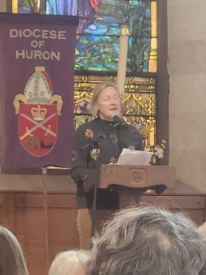

Respectfully Submitted by Donna Whiteside and Michelle Hughes
2025 Lay Delegates to Synod

SAFE CHURCH
ANNUAL REPORT FOR 2025

Screening & Police Records Checks 2025
During the past year, 6 PRC’s were completed and 4 applications are in progress. Apart from the pending approvals, PRC’s are up to date for all current high risk positions.
Individuals will be advised of the need for renewal in 2026 if they continue as an incumbent in such a position

Safe Church Screening
Safe Church screening is required by St. George’s Safe Church Policy for all staff and volunteers occupying high risk positions (see table below). Screening consists of an approved Police Record Check (within the past 3 years) and a review of the applicable position description and Safe Church Guidelines to minimize risks associated with the position.

Screening procedures apply to any individuals assuming a new, high-risk position as a result of a Vestry appointment or election. A renewed police records check is also required if 3 years has elapsed since the last check.

Staff, clergy and wardens are required to process their police records check through the Diocese using XpressChek. The XpressChek application form is available from the Church office or from the Safe Church Coordinator. It is processed by the Church office and uploaded to the Dioceses. All other police checks are submitted by the applicant using the OPP portal at https://www.opp.ca/index.php?id=147&lng=en. When applying for a PRC via the OPP portal, please note that you are applying for a “Criminal Records Check” NOT a Vulnerable Sector Check. Before starting the application process, you will need to have obtained a copy of the Diocese authorization letter, personalized for you, from the Safe Church Coordinator. You will also need a copy of an identification document (e.g., drivers licence or passport). These documents should be available in an uploadable format (pdf or jpeg) before initiating the application process.

High-Risk Positions | Position Responsible for Recruitment Screening and Annual Risk Review
Rector  Associate  Postulant for the Diaconate  Warden  Parish Administrator  Youth Ministry Coordinator  Youth Ministry Teacher  Treasurer  Coordinator Carriage House Activities  Plant Sale Coordinator  Money Counter Coordinator  Custodian  Lay Reader  Lay/Pastoral Care Visitors  Organist/Choir Director  Sexton | Wardens/Safe Church Coordinator (SCC)  Rector/ SCC  Rector/Associate/  Rector/Warden/SCC  Youth Ministry Coordinator/SCC  Rector/Warden/SCC  Warden/SCC  Warden/SCC  Warden/SCC  Warden/SCC  Warden/SCC  Rector/Warden/SCC  Rector/SCC  Rector/SCC  Rector/Wardens  Rector/Wardens

Respectfully submitted,

Dr. Garth Martin
Safe Church Chair

PRAYER AND CARE MINISTRY

“And whatever you ask in prayer, you will receive, if you have faith”

Matthew 21:22

In connection with the Anglican Fellowship of Prayer, we are a small, but growing,
group devoted to prayer, petitions and intercessions for those in need. We are
pleased that our Prayer Team at St. George’s has recruited new members over the
past year.

All names, received in confidence, are prayed for in faith, that God’s love and compassion will bring the healing and restoration in body, mind and spirit as
needed.

Anyone needing prayer or interested in becoming a prayerful servant of Christ can
contact Donna Whiteside at dbwhiteside1973@gmail.com.

Prayerfully submitted by Donna Whiteside

OUR WOMEN’S ‘TAKE TIME’ PRAYER GROUP

During 2025 the Women's Take Time group met to learn, pray and care for one another. We studied the book of Ephesians and the 23 third Psalm. We are an interdenominational group that welcomes all women who wish to attend. We plan to resume our meetings in February 2026 at 6:30 pm on Monday evenings.

Curious to explore more, feel free to connect with me at:
Cell: 647-221-1655 or email: 5jannicholson@gmail.com

All women are always welcome!

Respectfully submitted,
Jan Nicholson

ST. GEORGE’S CHANCEL GUILD

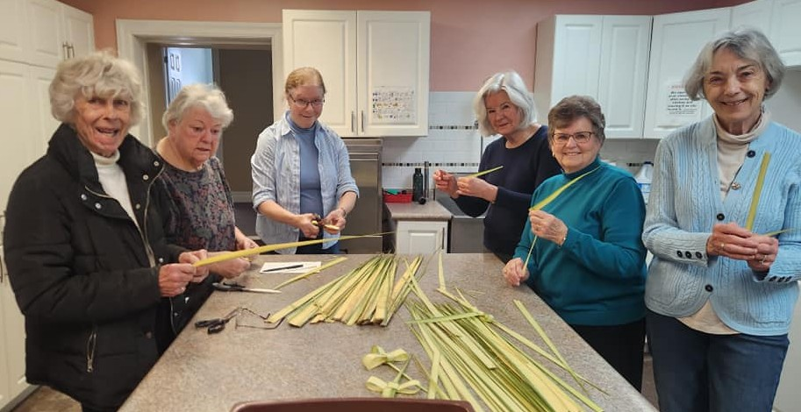

St. George’s Chancel Guild is a committed group of parishioners whose ministry it is to prepare the altar each week for Sunday worship and to pick up flowers from Foodland, if they have been ordered.

In this past year, there have been four leaders: Adele James, Ruth McWhirter, Sue Abbotts and Caroline Bacher; each responsible for a three-month period. We usually have a partner to assist us in our duties. However, we can request assistance from a few others who are on our list, who help out on an occasional basis.

Our duties include counting out the small hosts for both services, preparing the priest’s host and pouring the wine into the flagon. The elements, the flagon and silver cup holding the hosts, are placed on the back table at the entrance to the nave.

The priest’s host is placed on the Altar and is covered with a veil and purificators. We also make sure that water has been poured into the cruet, which is placed on the small table beside the altar along with the silver basin and lavabo towel. We replace the presence candles when they are extinguished.

At the end of each service, the silver is washed and put away, flowers are placed in containers to be distributed. The purificators are taken home to launder.

Please know that we would love to have additional parishioners join us in this important ministry. If you are curious about the role or how you might give it a try, please reach out to Canon Gray or to one of us.

Respectfully submitted by,
Caroline Bacher, Adele Denyer, Ruth McWhirt and Sue Abbots

THE SANCTUARY LAMP

The Sanctuary Lamp burns continuously each month to the Glory of God and in memory of our
loved ones.

Some months, we have more than one name lovingly remembered by families.

The suggested donation amount is fifty dollars a month for this remembrance, made payable to
St. George’s Anglican Church.

If you wish to add a name for 2026, please contact the office by emailing:
parishofthebluemountains@gmail.com or by calling Judith Helston at 519-599-5947.

Respectfully Submitted by:
Judith Helston

MONTHLY LIST of Memorial Names Observed in 2025
MONTH | GIVEN BY | IN MEMORY OF
January 2025 | Carol Blasdale | My baby daughter Alex and son Jay
 | Susan & Perry Hoadley | Betty Brown
February 2025 | Ruth & Doug McWhirter | Gordon & Ida Ardiel
March 2025 | Monica Wilkinson | Reg & Margaret Wilkinson and Oliver, Bertha and Laine
April 2025 | Sue Abbotts | My family – Mary, Lloyd, Dennis and Lorna Hale
May 2025 | Loriena & Grant Forsythe | Our parents Greta & Alex Webb and Maitland & Jean Forsythe
June 2025 | Jean Tyler | For our loved ones
July 2025 | Elizabeth Ross | For my Ashton Cockshutt family and husband Peter Ross
August 2025 | The Noble Family, Anne & Eleanor | Our Brothers Peter and Ron
September 2025 | The Noble Family, Anne & Eleanor | Our Parents Alice and Neville Noble
October 2025 | The Bowcott Family | Steve Bowcott, Gray+’s father
 | Walter Schmidka | My Wife Gertrude
November 2025 | Gail Rows | Husband Glen & loved ones
December 2025 | John & Judith Helston | The Milner and Helston Families

SANCTUARY AND ALTAR FLOWERS

Thank you to our parishioners who have donated flowers in memory of their loved ones this past year.

We continue to have our fresh flowers from Foodland. Cori is very creative and we are thankful for her assistance.

The cost is $125.00 for the two arrangements, payable to St. George’s Anglican Church by cheque or e-Transfer.

Please let me know of your wish to contribute memorial flowers, month and date, by call Mary Sandell at 519-599-5512 or the church office.

It is not our custom to have flowers on the altar during Lent, but if you wish to remember a loved one during this season, please consider a donation towards the Easter flowers, when the memorial names will be remembered and celebrated.

Respectfully Submitted by Mary Sandell

ST. GEORGE’S ALTAR SERVERS GUILD

It has been almost a year since I offered to serve in this role and I have learnt much about the protocol involved.

My duties as an altar server include lighting the altar candles and small votives before the 10 a.m. service begins. As crucifer, I carry the processional cross leading the choir, priest and diaconate postulant to the Sanctuary. For the Gospel reading, I lead the gospeller, with the cross, to the centre of the church.

During the communion, I assist the priest and diaconate postulant at the altar in serving the host and wine. When the service has concluded, I lead the choir, priest and diaconate postulant from the Sanctuary to the Nave for the closing hymn. I am responsible for snuffing the altar candles and votives after the service.

I would welcome anyone interested in serving alongside me in this ministry.
If you would like to learn more, please connect with me or with Canon Gray.

Respectfully submitted by
Caroline Bacher

MONDAY BRIDGE GROUP

Drop in Bridge enjoyed a good year, and was pleased to welcome some new members with an increase in participation. Hopefully, this will be a continued trend for 2026.

We were pleased to be able to annually donate $1,000.00 in support of St. George’s and its ministries.

Thanks to Bruce Whiteside for the weekly setup. This is a great blessing for the members of this group.

Interested in playing Bridge? Consider joining us for fun times and a sense of community. Join us on Monday afternoons, weekly.
Submitted by Adele James

TUESDAY MAHJONG GROUP

Our newest group at St. George’s is a Probus group that started playing Mahjong this year in the parish hall on Tuesday afternoons. Mahjong is a complicated game to learn, but it is getting easier for the participants week by week!

We thank Saint George’s for letting us rent this comfortable space, which has become home to an average 12 players per session.

One of the special highlights of Mahjong this year was to enjoy our first season with St. George’s Pollinator Garden. Sometimes the activity in the garden was as much a distraction for us as the games themselves! We really enjoy its beauty just outside the windows in the Parish Hall where we gather.

On behalf of the Mahjong Group, thank you! Regards, Adele James



ST. GEORGE’S CARES
OUTREACH MEAL PROGRAM & CATERING GROUP

St. George’s Cares Outreach meal program and catering group has the capacity to prepare between 30-40 seniors meals every other Thursday. At the end of the 2025 year, we were delivering meals to 30 seniors in our community. This ministry continues out of the proud work that began as part of St. George’s response to the Covid pandemic.

Within each meal delivery, we serve a soup, salad, dinner entrée, dessert and a bun. Many
seniors comment that the delivery lasts them more than a day or two!

We have two teams headed by Janine Clark and Barbara Wade and the group of volunteers who prepare and cook these meals from scratch. Doreen Taylor does an amazing job of preparing and cooking the soup and desserts.

We are also deeply gratefully for our team of drivers who deliver these meals during any weather.

One exciting development in our 2025 year, was the receipt of two significant donations in support of our Senior’s Meal: 1) we received $5,000 from the Craigleith Cares Foundation, and 2) we received $4,000 from the Loyal True Blue and Orange Home in Richmond Hill, with funds also from the local 1396 Loyal Orange Lodge.



Lastly I want to give a special shout-out to our Program Consultant, Ruth McWhirter whose recipe book and her wisdom and direction in helping out our volunteers has made 2025 another successful year.

Our catering group continues to serve the Thornbury-Clarksburg Rotary every other Thursday evening providing a full meal and a vegan meal option. We have a dedicated team of volunteers, shoppers, and cleaner-uppers.

If you want to join this happy, fun group, please connect with Adele James or leave a message with the Parish Office. A huge thank you goes out to all those who make this ministry such a successful endeavour.

With appreciation,
Adele James, on behalf of the St. George’s Cares Program.

OUTREACH TO MEXICAN PARISHIONERS

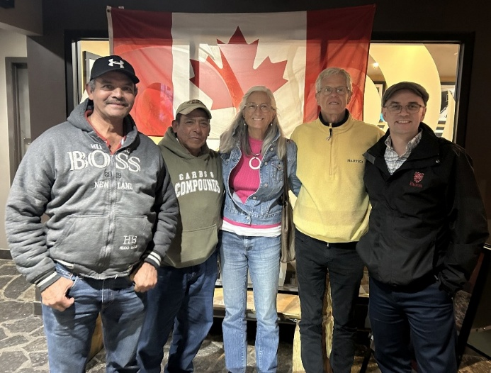

For more than twenty years, St. George’s has had a special relationship with Mexican parishioners who have come to work each harvesting year in the Blue Mountains, and, in more recent years, transitioned to employment on other parts of the Saugeens Region. Originally, these men were able to worship with us on Sundays. The Marion Icon, which hangs in our Sanctuary, was a gift from them to St. George’s to say thank-you for being their home church away from home.

This year we were able to visit our dear friends Daniel and Luis, hosting them for a dinner out and a chance to share stories about family, work routines, health and faith. Both of them are very well and always asking about their St. George’s friends (a special shout-out to John and Carol Hethrington!).

Luis and Daniel continue to balance the challenges of caring for family at home while navigating the countless protocols that allow for them to seek employment seasonally here in Canada. They were able to find work in Port Elgin in 2025, and hope to be able to be there again in 2026. Their spirits are always high, and we cherish our time with them.

We continue to give thanks for our relationship with these special parishioners that has spanned many years and pray for them and their families in 2026.

Until we meet again in our journeys – may God bless them.

Respectfully submitted, Jim Moore

THE ANNUAL COMMUNITY CORN ROAST

God blessed us with another year of good weather for our 2025 Annual Corn Roast. We were grateful for all the volunteers who helped to make this event a success and enjoyed by the members of the community who came out to support us.

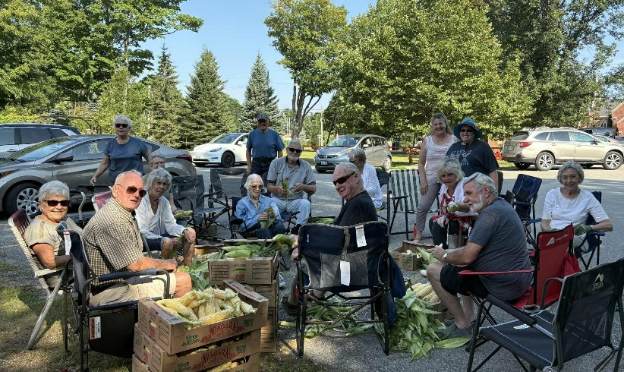

The local Branch 281 of the Royal Canadian Legion once again set up their pop up bar serving beverages of the alcoholic variety to our guests.

Our good friends from Grace United Church’s Green Team were on hand to clean and recycle dishes, cans etc. We thank them for their diligence in helping to keep our beautiful green space, green.

This year’s recipient of the funds raised through donations was the Thornbury-Clarksburg Rotary club, who received a cheque for $1000.00. The cheque was gratefully accepted by the members at their meeting.



One observation noted this year was that we will be aiming to have more active participation from our recipients at the event itself. In 2026 we hope to partner with Event for Life, a well-known community organization in the Blue Mountains.

ST. GEORGE’S 8:00 A.M. WORSHIPPING COMMUNITY

For skiers, gardeners, golfers and people who can’t sing (there is no music) the 8 o’clock service at St. George’s is the best way to get an early start on Sundays. Where else can you get a cheerful greeting, coffee plus a snack on arrival, Gray’s Cafe, a collect, 2 lessons, a sermon, your sins forgiven, plus wine and a cookie, and be out by Nine?

And this early-hour service is now attracting more people every month. In 2000 there would be just 10 or 12 at the 8 o’clock service. By 2014 it had grown to an average of 16. Just before the COVID Pandemic, attendance per week had grown to 20-22. Our service consistently fluctuates between 20-25 worshippers, depending on who's away during the winter months. The growth of the 8 o’clock service has contributed substantially to the overall growth of our whole congregation.

What brings all of us out so early in the morning is the complete, thoughtful and well-organized service. To make it more welcoming, one or more of our Wardens is always on hand to greet each parishioner at the door and offer a special welcome to anyone who is new.
Donna Whiteside supplies and prepares both decaf and regular coffee and has a tray with 2 dozen tasty treats, including buttered raisin bread! Unlike the 10 o’clock service, we have our fellowship before our service.

And if we are not finished when Gray starts the service, we can take our coffee to our pew. The service is quite informal, with lots of interaction between Gray and this growing congregation. If we notice someone new in the pews, we make a point of introducing ourselves and welcoming them to St. George’s.

I trust that we can continue to attract more new members to St. George’s 8 o’clock services. So, if you have an early tee time, or want to be first on the slopes, or get into the garden fast, come out to the 8 o’clock services for a unique and rewarding experience.

Respectively Submitted by John Hethrington

SOCIAL MEDIA AND ADVERTISING

Since the beginning of the 2020 pandemic, St. George’s has fully embraced the technological tools at our disposal to continue to reach out to new people and to maintain the growing relationships of our membership with the wider community.

Each Sunday, our 10:00 a.m. Sung Holy Eucharist Service is livestreamed on our official YouTube site (https://www.youtube.com/channel/UCH2QRTboosu4S-lHVXaklWw), or search The Anglican Parish of The Blue Mountains. Our site hosts 562 worship videos and has 247 subscribers. Average weekly viewing includes 41 participants (with 175 regularly documented viewers).

We are thankful for the ministries of Gloria Andrews, who oversees the video recording of our 10:00 a.m. service, and for Laura Woolner, who maintains our Facebook Page (St. George’s, The Parish of The Blue Mountains), which has 604 followers. Laura also oversees our weekly e-blast newsletters.

For any parishioners not receiving the weekly e-blast newsletter, please contact the office at: parishofthebluemountains@gmail.com and we’ll gladly set you up!

Social media continues to be a wonderful way to inexpensively advertise our church and its ministries. With thanks to all of our supporters in the wider community, many of our event-related posts attract as many as 1000s of views per event.

If there is ever any further improvements that we can make to our social media ministries, please pass along the tips to us. Thanks for your continual support of this ministry.

THE PRIMATE’S WORLD RELIEF AND DEVELOPMENT FUND (ALONGSIDE HOPE)

A Letter of Thank-you from The Ahli Arab Hospital in Gaza

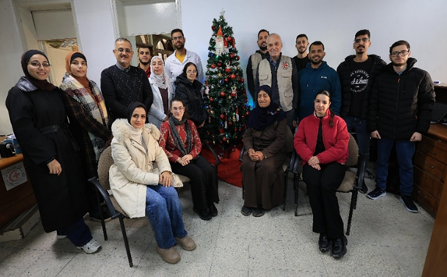
Dear Friends and supporters from St. George’s in the Blue Mountains,
This Christmas, after two long years marked by war, loss, and uncertainty, the Al-Ahli Arab Hospital community chose to pause and quietly affirm hope. For the first time since the war began, our staff came together to decorate a Christmas tree within the hospital grounds.
This simple act carried deep meaning. It was not a celebration of ease, but a gentle declaration of resilience, faith, and life. Amid exhaustion and grief, our doctors, nurses, and staff wished to create a small space of light for patients, families, and one another—reminding us that hope endures even in the darkest times.
At Al-Ahli, Christmas has always meant standing with the suffering and bearing witness to compassion. We are deeply grateful for your partnership, prayers, and steadfast support, which continue to sustain our mission of healing and service.
We wish you a blessed Christmas filled with peace, renewed hope, and the promise of better days ahead. Thank you for being with us.
With gratitude,
Dr. Suhaila Tarazi
Director General
Ahli Arab Hospital-Gaza

A Letter of Thank-you from the Dzherelo Centre in Ukraine



Dear friends from St. George’s Church in Canada,

During these Christmas days, we send you our heartfelt greetings on behalf of the entire Dzherelo community: children and young people, parents, and our team. Thank you for being close to us with your thoughts, your hearts, and your prayers.
Christmas comes quietly, with the newborn Child, with the faith of Mary, with the warmth and comfort of home. It reminds us that love and light are able to sustain us even when the world is experiencing uncertainty and pain. Thanks to your support, this light touches the lives of our children and families every day. Thank you for your care, support, and prayers.

We wish that these festive days bring all of us inner peace, warmth, and inspiration. May prayer be a source of strength, and faith a daily support. May the Christmas star lead us along the path of hope and mercy. And may the Lord protect each of you and your families, and all those who are especially in need of support today.
We sincerely thank you for your trust, support, and the good that you create together.
Christ is Born! Let us glorify Him!
With sincere gratitude,
Zoreslava and everyone at Dzherelo Centre

THE 2025 PLANT SALE REPORT
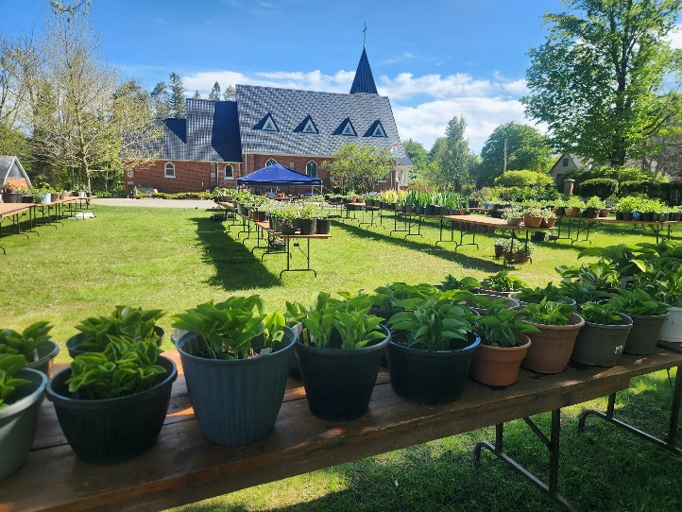

2025 Plant Sale: May 24, 2025
2026 Plant Sale: May 30, 2026

The 2025 St George’s Plant Sale was a successful community-building and fundraising event that brought together parishioners, neighbours, and local gardening enthusiasts in a shared spirit of generosity and service. The sale is a visible expression of St George’s care for the wider community—inviting people to share the abundance of their gardens while supporting outreach that enhances lives locally and internationally.

Key Outcomes and Results: For 2025, the leadership team focused on reducing the overall workload while improving quality. This was achieved by encouraging gardeners to donate fewer but larger, healthier plants, in order to achieve a higher average price per plant. This approach proved successful. By noon on sale day, total gross revenue exceeded $10,000—more than $1,000 higher than the same point in the 2024 sale—despite fewer plants sold, and the higher quality plants resulted in a higher price per plant on average.

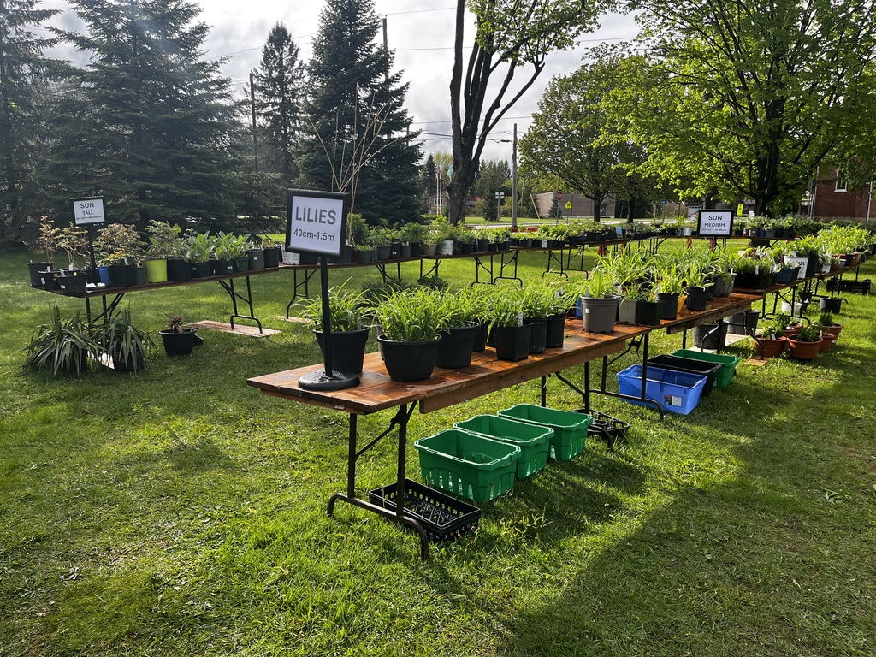
Approximately 60 volunteers contributed time and energy in 2025, supporting digging, potting, pricing, plant care, set-up, sales, and hospitality. The sale was held one week earlier than in 2024, requiring flexibility in response to different weather conditions. Volunteers adapted creatively and worked together with good humour and resilience.

Looking Ahead and Getting Involved: The 2025 Plant Sale demonstrated that a thoughtful focus on quality, sustainability, and community engagement can strengthen outcomes while reducing volunteer burden. Planning is underway for the next plant sale on May 30, 2026.

Members of the congregation and the wider community are warmly invited to participate—by digging, dividing, and donating plants from their own gardens; by assisting frail or less mobile gardeners who can no longer manage this work themselves; or by volunteering during plant sale week. With vestry’s continued support, the Plant Sale will remain an important expression of St George’s stewardship, generosity and community engagement.

Respectfully submitted,
The St George’s Plant Sale Leadership Team

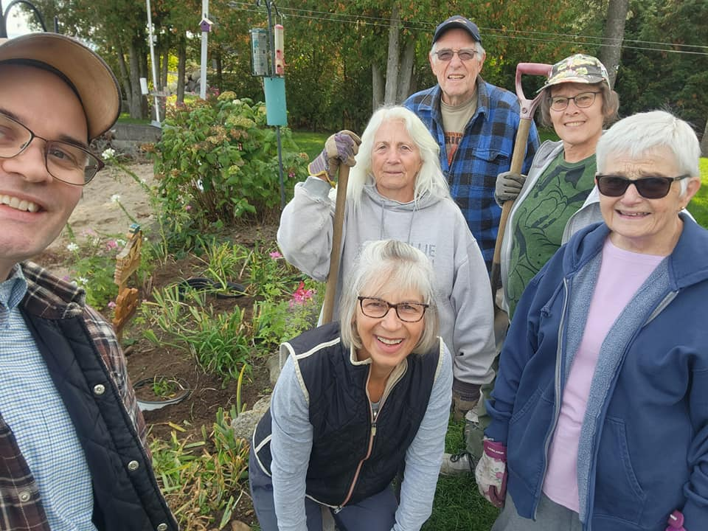

THE 2025 GARDEN PARTY – FISH FRY

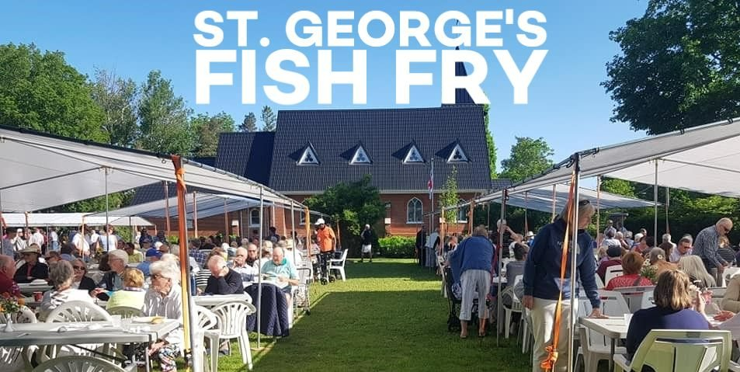

This annual event takes place on the third Saturday of June. Ribey’s Catering provides the delicious pickerel and the volunteer ladies of St. George’s make the salads. Pies are ordered from local bakeries.

Coffee, tea and lemonade are also served. Entertainment from the Beaver Valley Pipes and Drums Band was well received and we hope to continue with a musical programme. We give thanks for the partnerships that we have with the Thornbury-Clarksburg Rotary Club, who provide our tents at a discounted price; with the Beaver Valley Branch of the Royal Canadian Legion, who operate a bar service for our guests; and the Grace United Church Green Team, who help us to reduce our waste and recycle as much as possible. These partnerships truly make our Annual Garden Party a community event!



Tickets for this event were sold from Pharmasave as well as on-line and in the office by appointment. Some tickets were also sold after the two church services and at the Plant Sale.

The event was well attended and we were able to continue outside despite the forecast for rainy, windy weather, in which case we were prepared to move indoors. The Presbyterian Church was very gracious in allowing us to use their premises if it was required.

We were thankful for the many volunteers who came out to help; those who helped prepare the salads, ordered and delivered the pies, set up the tables the day before, placed the placemats and cutlery, served under the tents and made the coffee, tea and lemonade, those who helped carry the salads and those who helped clean up in the kitchen. There are so many jobs that are required to make this event a successful one and we thank all of you who volunteered.

Respectfully submitted by,
Caroline Bacher and Adele James

CARRIAGE HOUSE WINTER STORAGE

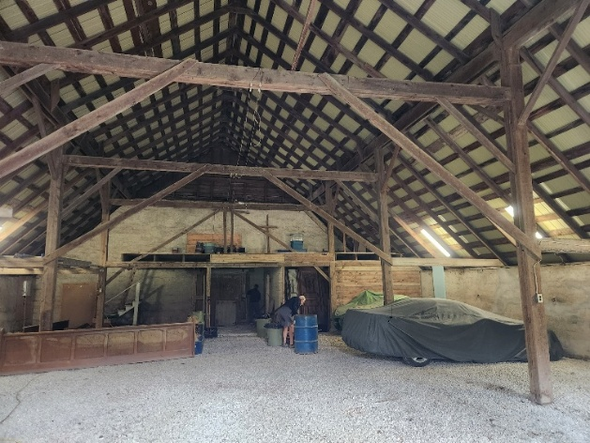

This is our 6th year of renting out the Carriage House Shed for the October 15 – May 1 winter months.
- 10 cars stored in 2021/2022
- 11 cars stored in 2022/2023 (9 returning - 2 new renters)
- 13 cars stored in 2023/2024 (7 returning - 6 new renters)
- 19 cars stored in 2024/2025 (9 returning - 9 new renters) – includes 1 Harley Davidson and 1 trailer with 2 canoes
- 20 cars stored in 2025/2026 (12 returning – 8 new renters – includes 1 Harley Davidson and 1 small boat)
Rates were kept the same as 2024 at $450 with 11 people taking advantage of a May 1/25 “Early Bird” renewal rate of $400. Total 2025/2026 revenue generated $8,755. We were sold out before the end of July and turned many renters away.

We received a substantial donation from one of our members for structural improvements to the Carriage House that allowed us to complete the following work:
- Masonry repairs to the walls
- Install a 60-amp hydro pony panel
- Re-enforce mezzanine floor for storage
- Installed 2 additional security cameras (one inside and 1 at back of Carriage House)
- Added car turn-a-round area in front of Carriage House
- Ruth provided a 2nd window painting
We plan to upgrade the lighting in the Carriage House in 2026 with a long-term plan for a cement floor.

I would like to thank Tom, Brian & Rev. Gray for their assistance this past year.

Blessings,
Hank Bouwman

ST. GEORGE’S MEN’S GROUP

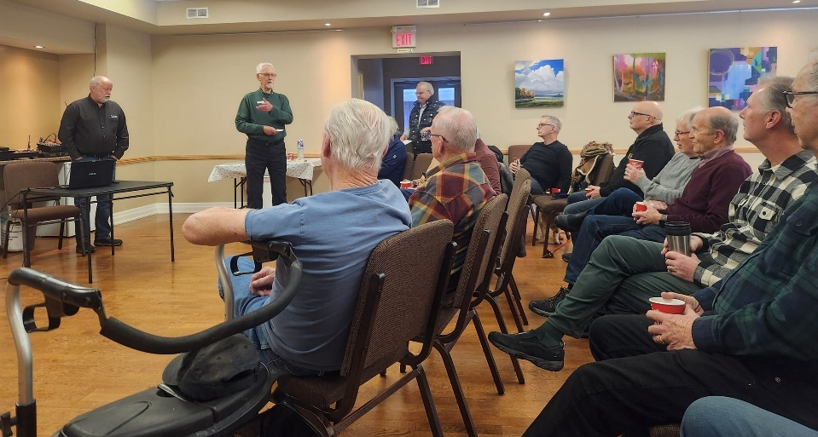

Our Men’s Group restarted in September 2023 and meets at 8:30 am on the 2nd Saturday of every month (except in July & August).

We have from 12 – 24 men participate each month. We usually have coffee & Tim Bits followed by a guest speaker on various topics.

The ACW Ladies have prepared and served us some delicious meals on 4 occasions in 2025. We take up a collection to help pay for the breakfast and donate it to the ACW.

We were very fortunate in 2025 as we had a list of speakers with a variety of topics with all presenters donating their time and expertise. Average attendance of 17 / month.

Thank you to the ACW Ladies for getting up early to make us breakfast and to Gary Huber & John Leckie for providing the coffee & Tim Bits.

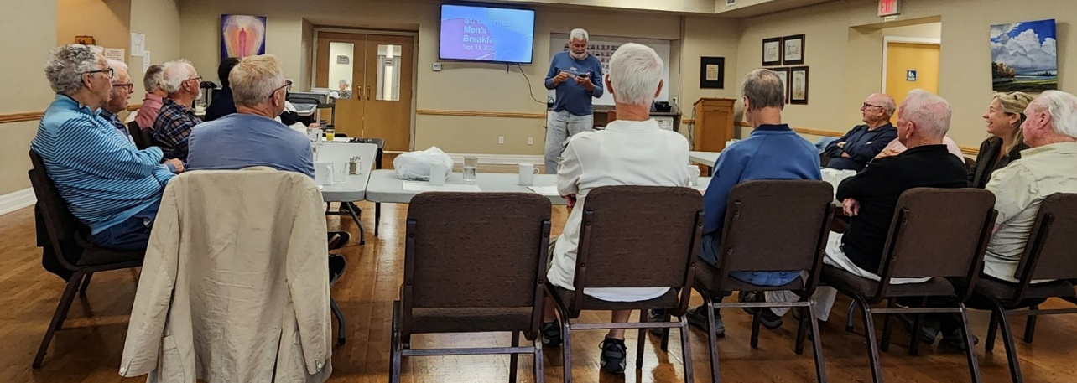

Feel free to invite your friends to join us each month.

Blessings,
Hank Bouwman

SEXTON’S REPORT
(BUILDING AND PROPERTY MAINTENANCE)
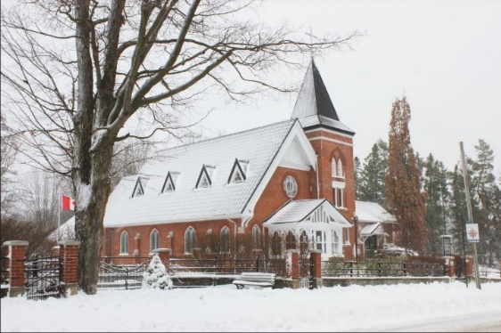

St. George’s is in great shape!

I’m especially proud of the work that has been done in the Carriage House. It now houses more cars and at least one less squirrel.

Looking ahead, the Wish List for 2026, in order of importance is:
- Painting of the Sanctuary, $3-5,000
- Removal of poplars behind the Carriage House, $7-10,000
- Back deck of Rectory rebuilt, $5-7,000
- Gutters cleaned, quote to come

I’m proposing a 10% increase across the board on the winter car storage rates in the Carriage House. We have spent over $12,000 in repairs and upgrades this year, including security cameras and the storage spots are sold out for this coming winter. New rates are proposed at:

Winter storage $499 (up from $450)
$449 early bird special (up from $400), before May 1st for next winter
$275 for summer storage (up from $250)
Over 15 feet in length = additional $35 per foot (up from $25 per foot)

The church across the street charges $400 but they have done no upgrades to their facility. These new rates should bring in an additional $1000.

We are asking for approval of the new rates from the Parish Council.
Note: These rates have been approved by the 2025 Parish Council for the 2026 Operating Year.

Thank you to the many volunteers who help, in various ways, to keep St. George’s an organized, safe and well-maintained property.

Respectfully submitted,

Tom Kern, Parish Sexton

ANGLICAN CHURCH WOMEN’S REPORT

We are thankful for all the leadership of our women at St. George’s!

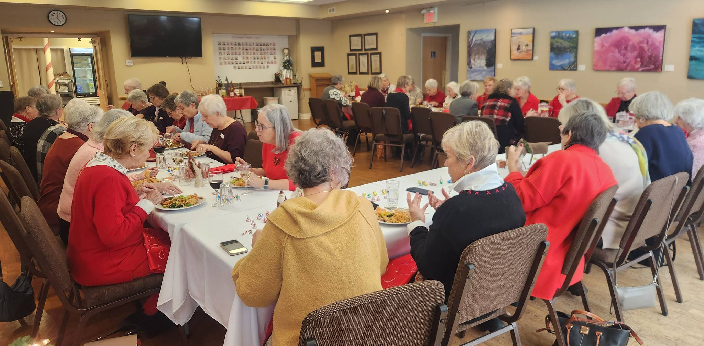

President: Adele James
Treasurer: Gloria Andrews
Secretary: Mae Farmer
30 Active Members

The ACW meets eight times a year, March to June and September to December on the first Tuesday of the month at 2pm in the large hall at the Church. All women of the parish are welcome.

2025 was again a busy year. In February we helped with the pancake supper at the community centre. Donations from the supper went to Boots on the ground for first responders counselling services.

May 10th was our very successful boot sale and special thanks to the Lions Club for once again serving peameal bacon on a bun.

The ACW members are active throughout the summer months helping with the fish fry and corn roast. We also catered for 4 funerals in 2025. We supported Huron Church Camp for $1500.00. The ACW donated $4000.00 towards the Church gap.

September saw us start our preparation for the Jolly Holly Bake Sale and Lunch. It was a huge success including 20 cookie trays, bake table, craft table as well as the very popular lunchroom.

At our October meeting we had an OPP Officer come and talk about Senior Safety.

We also catered for The Bishops supper. A delicious meal of prime rib dinner.

November is spent in preparation for the Bazaar cookie making, baking, soup making, meat pie baking. The new meat pies and frozen lasagna were a huge success and we sold out.

Our year end in December we enjoyed a fabulous Chinese lunch at the Church.

We are grateful to all the women of the Church for their time and support in volunteering at many of the Church’s events.

Faithfully submitted by,

Adele James, ACW President

ACW FINANCIAL REPORT (2025 Year in Review)
This past year has been a busy one for the women of the ACW. We are blessed to have such a dedicated and resourceful group who will apply themselves wherever they are needed. And boy were they needed this year!

The ACW has spearheaded several fundraising events this year which has increased our monetary account in that we were able to donate to projects within St. George's and outside our doors.

Each year the ACW has made a contribution of $1500.00 to the Huron Camp, to support 2 campers who do not have the financial means to attend the camp.
After the discovery of the original architectural drawings of the church, the ACW decided to fund the cost of the framing at $1,995.00 for 5 of the drawings. They are now on display in the Parish Hall. A shout out to Beyond Framing in Clarksburg for their attention to detail in this endeavour.

The ACW donated $250.00 to assist with the creation of the beautiful Pollinator garden as envisioned by Michelle Hughes, outside the windows of the Parish Hall.

Our president, Adele James realized that it was difficult to admire the riot of colour outside the Parish windows so it was decided that the ACW would fund the cost of $200.00 to have the windows cleaned.

When Goldsmith's put the word out for donations toward their Jamaican fund, we made a donation of $200.00. Goldsmith's have been great supporters of St. George's community outreach.

At year's end the ACW makes an annual donation to St. George's usually around $2000.00, this year we are able to gift $4000.00. As treasurer, I would like to applaud each and every one of you in whatever capacity you gift to the ongoing operations of St. George's ACW. It is due to your hard work that we can financially support a variety of initiatives.

Respectfully Submitted by

Gloria Andrews, ACW Treasurer

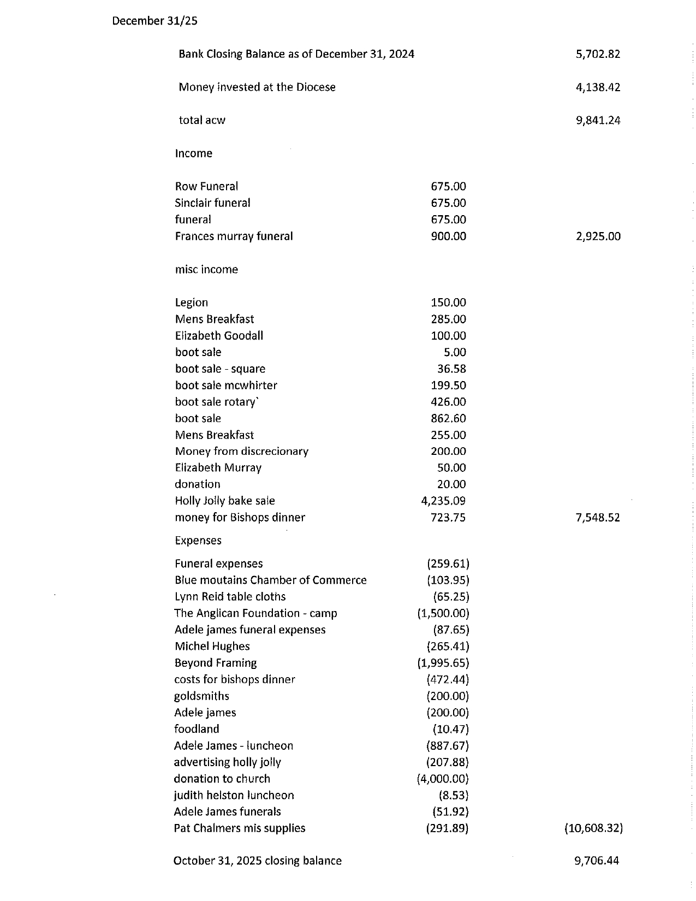
ACW Financials faithfully submitted,
Gloria Andrews
ACW Treasurer

TREASURER’S REPORT

Treasurers’ Report
2025 Financials and Budget for 2026
1. Gratitude for Parishioner Support
On behalf of the treasurers, we extend our heartfelt thanks to all parishioners for your generous donor contributions throughout the past year. Your steadfast support has enabled us to sustain our ministries and operations effectively. As detailed in Canon Gray’s report, these funds have directly fueled our outreach activities, making a meaningful impact in our community and beyond.
2. Proposal to Enhance Church Budget Process and Optics
We have been discussing ways to refine our budgeting approach.
Our year-end budget gap has consistently resolved positively, which is a testament to our parish and community’s generosity. However, the annual stress and uncertainty during the final six weeks of the year—despite always working out over many years—may unintentionally create negative perceptions.
Are we risking an image of financial vulnerability when, in reality, we are one of the most fiscally stable churches in the region? Since success often attracts further support, we should prioritize projecting confidence and resilience rather than urgency in our December appeals.
To illustrate, rounding our budget to approximately $310,000, here’s a preliminary breakdown of potential funding sources designed to promote earlier commitments and minimize year-end pressures:
- Preauthorized Debit Giving: $105,000
- Plate Collection: $80,000
- Fundraising Events, Rentals, and Miscellaneous: $50,000
- Pledges: $75,000 (to be secured over the course of the year, rather than through a concentrated gap-closing push in November and December)
This is the core concept. The above figures and categories require further refinement upon approval of the budget after Vestry.
3. Closing Thanks and Prayers
Once again, thank you to everyone for your continued dedication and contributions. We pray for another prosperous year in 2026, both fiscally and spiritually, as we grow together in faith and service.

Warm regards,
Gary Huber and John Leckie
Treasurers
Note: for details on how to sign up for Preauthorized donations, or to change your monthly donation amount, please connect with us through St. George’s office at: parishofthebluemountains@gmail.com

FINANCIAL PACKAGE
VESTRY 2026 (2025 IN REVIEW)

Contents (Included at the Back of the Vestry Package):

- Income and Expense – December 31st ,2025 and Budget 2026 (2pgs)
- Asset Management Report – December 31st, 2025
- Donations Profile 2025 (Envelope Secretary’s Report)
- 5 Year History and 2026 Budget

APPOINTMENTS & NOMINATIONS FOR THE 2026 YEAR

1. Election at Vestry:

Tina Rogers Vestry Clerk

2. Appointments to Parish Council by the Rector:

Janet Cringle Ex-Officio Member (Director of Music)
The Ven. Judy Walton Ex-Officio Membership (Honourary Associate Priest)

Donna Whiteside Guest Member (Postulant for Ministry)
Michelle Hughes Guest Member (Postulant for Ministry)

Tom Kern Rector’s Warden
Tina Rogers Deputy Rector’s Warden

Current Vacancy Parish Council Secretary
Caroline Bacher Chancel Guild Coordinator & Worship Planning Team
Sharon Wigle Youth and Family Ministry Focus

3. Nominations from the Nominating Committee for the Year 2026:

Nominations for People’s Warden
Adele James People’s Warden

Nominations for Deputy People’s Warden:
Pat Chalmers Deputy People’s Warden

& any names from the floor

Election to follow.

4. Nominations for General Members to Parish Council:

The Nominations Committee Chair will present the names of those wishing to stand for 2026 from the floor of Vestry

& any names from the floor

Election to follow

5. Nominations for Committee Chairs/Leadership;

Gary Huber, John Leckie, and Gloria Andrews
Parish Treasurers and Envelope Secretaries

Dr. Garth Martin Safe Church Chair

Donna Whiteside Anglican Fellowship of Prayer Diocesan Representative

Adele James St. George’s Cares Coordinator
Ruth McWhirter St. George’s Cares Outreach Consultant

Michelle Hughes, Richard Griffith, and Elaine Beard

Enviro Action Representatives (Creation Care)

Hazel DeBurgh Plant Sale Coordinator
John Hethrington Plant Sale Consultant

Richard Griffith Primate’s World Relief and Development Fund (Alongside Hope) Representative

Election to follow.

6. Nominations for Lay Delegates to Synod (3 Voting Positions)

Nominations to be opened from the floor.

Election to follow.

Special thanks and recognition to the 2025 St. George’s Parish Council
for their leadership and ministry throughout this past year.

7. Rector’s 2026 Emeritus Warden Appointments:

Brian Blackie Emeritus Warden
Gloria Andrews Emeritus Warden

Submitted faithfully by the Rector in consultation with the 2026 Nominating Committee.

